Evaluation of the VIIRS aerosol EDR for Beta Maturity Level

Version 1.1

August 23, 2012

Prepared by the

VIIRS Aerosol Calibration/Validation Team

Table of Contents
Executive Summary 7
1. Purpose 10
2. VIIRS aerosol EDRs 10
3. Product maturity level assessed: Beta 10
4. Assessment 10
5. Data quality assessment objectives 11
6. Data quality assessment methods 12
6.1. Match-up strategies 12
6.1.1. VIIRS vs. MODIS 12
6.1.2. VIIRS vs. AERONET 13
6.1.3. VIIRS vs. CALIPSO - SM 15
7. Results 15
7.1. AOT 15
7.1.1. VIIRS vs. MODIS 15
7.1.1.1. Direct collocation 15
7.1.1.2. No collocation 18
7.1.2. VIIRS vs. AERONET 20
7.2. APSP 22
7.3. SM 28
8. Related Documents 29

Table of Figures
Figure 1.Global map of collocated VIIRS (left) and MODIS (right) AOT over land. 15
Figure 2. Global map of collocated VIIRS (left) and MODIS (right) AOT over ocean. 15
Figure 3. Global map of VIIRS AOT EDR difference (VIIRS-MODIS) over land (left) and ocean (right). Land and ocean are gray and black, respectively. AOT is plotted only for areas with collocated VIIRS and MODIS observations. 15
Figure 4. Scatter-density plot of VIIRS vs. MODIS aerosol EDR over land (left) and ocean (right). Only high quality (QF=3) VIIRS EDRs were used in the comparison. The solid line is the 1:1 line. 16
Figure 5. Monthly AOT EDR from VIIRS (left) and MODIS (right). 18
Figure 6. Time series of global VIIRS and MODIS AOT (solid line) and standard deviation (shaded area) for land (left) and water (right). Overall mean AOT is in top right corner. 18
Figure 7. VIIRS-MODIS AOT difference (left), and ratio of number of VIIRS retrievals to number of MODIS retrievals (right) available for the study period. 19
Figure 8. Scatter plot of Mean-to-Mean comparisons of VIIRS and AERONET AOT over land from Match-up 1 (left), Match-up 2 (middle) and Match-up 3 (right). 19
Figure 9. Scatter plot of Mean-to-Mean comparisons of VIIRS and AERONET AOT over ocean from Match-up 1 (left), Match-up 2 (middle) and Match-up 3 (right). 20
Figure 10. VIIRS-MODIS AOT difference (left) and VIIRS-AERONET difference (right). 20
Figure 11. Left: Scatter plot of over ocean VIIRS Angstrom Exponent calculated from AOTs at 0.865 and 1.61 µm vs. MODIS Angstrom Exponent derived from AOTs at 0.86 and 1.63 µm. High quality (QF=3) APSP is used. Right: Same as on the left except only Angstrom Exponents corresponding to AOT>0.4 are used (disregard dot-dash line). 22
Figure 12. Left: Scatter plot of MODIS vs. VIIRS Angstrom Exponent over land calculated from AOTs at wavelengths 0.445 and 0.672 µm (the MODIS 0.466-µm AOT was interpolated to the VIIRS wavelength 0.445 µm). High quality (QF=3) APSP is used. Right: Comparison of MODIS over land Angstrom Exponent with that from AERONET from Levy et al. (2010). 23
Figure 13. Maps of monthly mean VIIRS APSP EDR (left) and VIIRS-MODIS APSP difference (right) using non-collocated data. 23
Figure 14. Histogram of VIIRS and MODIS Angstrom Exponents from non-collocated data over ocean (left_) and land (right). Angstrom Exponents with all-quality and best-quality are compared. 24
Figure 15. Scatter plot of VIIRS vs. AERONET (Truth) APSP (Alpha, AE) over ocean using Match-up 1 (left) and Match-up 2 (right). Both are Meant-to-Mean comparisons. 25
Figure 16. Scatter plot of VIIRS vs. AERONET (Truth) APSP (Alpha, AE) over land using Match-up 1 (left) and Match-up 2 (right). Both are Meant-to-Mean comparisons. 25
Figure 17. Monthly map of dominant high-quality gridded (0.25ºx0.25º) VIIRS SM. 27
Figure 18. Monthly map of gridded (5ºx5º) VIIRS (left) and CALIPSO (right) dust fraction. 28
Figure 19. Monthly map of gridded (5ºx5º) VIIRS (left) and CALIPSO (right) smoke fraction. 28

Tables
Table 1. Statistics of VIIRS vs. MODIS AOT EDR differences from the direct-collocation comparison. 17
Table 2. Accuracy, precision and uncertainty from VIIRS vs. AERONET matchups of AOT. Type of matchup, number of samples (N), and method (P/M: Mean-to-Mean: M2M, or Point-to-Point: P2P) are indicated. 21
Table 3. Accuracy, precision and uncertainty from VIIRS vs. AERONET matchups of APSP. Type of matchup, number of samples (N), and method (P/M: Mean-to-Mean: M2M, or Point-to-Point: P2P) are indicated. 27

List of Acronyms
AE | Angstrom Exponent
AERONET | AErosol RObotic NETwork
AOT | Aerosol Optical Thickness
APSP | Aerosol Particle Size Parameter
CALIPSO | Cloud-Aerosol Lidar and Infrared Pathfinder Satellite Observations
CM | Cloud Mask
EDR | Environmental Data Record
EOS | Earth Observing System
FMF | fine mode fraction
IDPS | Interface Data Processing Segment
IP | Intermediate Product
JPSS | Joint Polar Satellite System
MAN | Maritime Aerosol Network
MAPSS | Multi-sensor Aerosol Products Sampling System
MODIS | Moderate Resolution Imaging Spectroradiometer
NAAPS | Navy Aerosol Analysis and Prediction System
NPP | National Polar-orbiting Partnership
QA | Quality Assurance
QF | Quality Flag
SDR | Sensor Data Record
SM | Suspended Matter
STD | standard deviation
VCM | VIIRS Cloud Mask
VIIRS | Visible Infrared Imaging Radiometer Suite

Executive Summary

There are three aerosol EDRs derived from VIIRS. They are the Aerosol Optical Thickness (AOT), Aerosol Particle Size Parameter (APSP), and Suspended Matter (SM).

It is the assessment of the VIIRS Aerosol EDR Cal/Val Team that the Aerosol Optical Thickness EDR and the Aerosol Particle Size Parameter EDR have reached the Beta Maturity Level starting with date May 2, 2012. There is a substantial difference in quality, however, between APS over ocean and that over land, the latter having no real quantitative value. This should be clearly communicated to the user. The Suspended Matter EDR is not at the Beta Maturity Level at this time.

The above assessment is based on both qualitative and quantitative analysis of the VIIRS aerosol EDRs. The VIIRS AOT and APSP EDRs have been compared with MODIS aerosol products and with AERONET products and observations. VIIRS Suspended Matter has been compared with CALIPSO products. Comparisons include direct collocations of various match-up criteria, and assessments of monthly statistics without the benefit of direct collocation. All comparisons have been applied to a uniform time sample (2 May 2012 to 2 June 2012). The one-month time sample is sufficient to identify major and obvious problems with the products, but is insufficient to confidently bound the products’ uncertainties. The uncertainties stated below are preliminary and will change as additional months of data are analyzed.

Aerosol Optical Thickness EDR: One standard deviation of VIIRS AOT EDR products fall within ±0.09 ±10% of collocated MODIS retrievals over land and ±0.02 ±10% over ocean. The same VIIRS product falls within ±0.13 ±15% of collocated AERONET over land and ±0.04 ±5% over ocean.

In all cases, the VIIRS AOT over land product is biased high (0.07 to 0.15) against comparable products in a global sense. The high bias is regionally isolated to darker surfaces where aerosol is expected to be dominated by fine particles, either smoke or pollution. Over brighter surfaces, in desert transition zones where the MODIS product is known to be high biased against AERONET, VIIRS is actually biased low against MODIS. In this limited data set it is not known whether this low bias near deserts results from overestimation by MODIS or underestimation by VIIRS. The high bias in dark territory is obviously a VIIRS problem, as it appears in collocations with AERONET, as well.

Over ocean, VIIRS AOT shows high accuracy (0 to 0.06) and precision (0 to 0.10). The correlation is especially tight for situations of high Angstrom Exponent (small particles), while the low Angstrom Exponent (large particles) situations introduce much of the noise in the retrievals. These low Angstrom Exponent situations may correspond to dust, or may indicate residual cloud contamination. VIIRS also shows low bias in dust outflow regions over oceans.

Aerosol Particle Size Parameter (Angstrom Exponent) EDR: The VIIRS Angstrom Exponent EDR product over ocean shows correlation when compared with MODIS, but is biased high. The VIIRS product draws closer to MODIS as aerosol loading increases. If AOT is greater than 0.4 then one standard deviation of APSP falls within approximately ±0.50 of MODIS. Preliminary AERONET analysis at coastal stations shows APSP falling within approximately ±0.40 of AERONET. The VIIRS Angstrom Exponent over land is showing no skill at this time.
Suspended Matter: The VIIRS Suspended Matter product shows omnipresent volcanic ash, which is introduced from the VCM, and has been determined to be an artifact. The product reports too much smoke and insufficient dust, and does not match the spatial patterns expected from other sensors. At this time, the product is of limited scientific value, but sources of the issues have been identified and a path towards major improvement is clear.
Quality Flags: All results above are reported for the highest quality products. Degradation of quality levels in land products leads to degradation in accuracy and precision. This is especially true for APSP (Angstrom Exponent) products. QF are extremely important for the VIIRS aerosol product. Differences between “high quality” and “all quality” for VIIRS are much larger than the same for MODIS.
The Team has also studied the possibility that VIIRS retrieval accuracy was dependent on geometry (scattering angle, solar zenith angle and sensor zenith angle), and found no evidence of any angular dependency.
Specific identified problems:
- Overall significant high bias in AOT over land, away from deserts.
- Artificially high AOT and APSP in the snow melt region.
- Low bias in AOT over ocean in dust outflow regions.
- Proportion of AOT attributed to small particles is too high over ocean.
- Currently no skill in retrieving APSP over land.
- Omnipresent volcanic ash in Suspended Matter and not enough dust.
- Improper ingest of NAAPS model data in low quality IP products (will be fixed in MX6.2; does not impact EDR).
- Missing EDRs in bowtie deletion region.
- Internal fire test fails to find any fires, even when large fires are known to be active.
- Angstrom exponent out of range flag only at extreme high latitudes, which seems unlikely.
- Snow and ice in strange places.
- Bad SDR is too omnipresent.
- In heavy dust/smoke plume regions, AOT could be flagged as out of range.

Work before Provisional Stage:
- Collocations against AERONET/MAN data over ocean,
- Determine reasons for high AOT bias over land, and for high APSP bias over ocean,
- Determine whether there is possibility for any skill in Angstrom Exponent over land,
- Continue investigations beyond this one month of analysis,
- Tune threshold to improve detection of dust over water,
- Lower AOT threshold from 1.0 to 0.5 to type SM,
- Implement subpixel snow/ice mask similar to MODIS to avoid issues with spring thaw.

Purpose
This document presents the results of the evaluation the VIIRS Aerosol Cal/Val Team performed to assess whether the VIIRS aerosol Environmental Data Records (EDRs) meet the requirements for Beta maturity level.

VIIRS aerosol EDRs
The operational processing of VIIRS data at the Interface Data Processing Segment (IDPS) produces three aerosol EDRs. These are
- Aerosol optical thickness (AOT),
- Aerosol particle size parameter (APSP), and
- Suspended matter (SM)

The AOT and APSP EDRs are derived from intermediate products (IPs) of like quantities retrieved for 8x8 moderate resolution (750 m) pixels. The SM EDR is produced for each moderate resolution pixel.

Product maturity level assessed: Beta
The Maturity Level assessed in the current document is level Beta.

A Beta quality product is an early release product with initial calibration applied. The product is minimally validated and may still contain significant errors (rapid changes can be expected). It is made available to allow users to gain familiarity with data formats and parameters, but the product is not appropriate as the basis for quantitative scientific publications, studies and applications.

Assessment
It is the assessment of the VIIRS Aerosol EDR Cal/Val Team that the following VIIRS aerosol EDRs have reached the Beta Maturity Level:
- Aerosol optical thickness both over land and ocean;
- Aerosol particle size parameter (when good quality (QF=3) data are used). Note, however, that there is a significant difference in quality between APSP over ocean and that over land. The APSP over land EDR has no quantitative value. Yet, it is recommended for Beta level because 1) AOT and APSP are in the same file, and quality of APSP over land should not prevent users from getting AOT, 2) it is a product derived from spectral AOT, and users could calculate it even if the APSP product is not provided, and 3) users have lived with this situation for years with MODIS because the MODIS Aerosol Team has stated that their Angstrom Exponent over land has no quantitative value, even though it is available in the same product file with AOT.
The suspended matter EDR is not at the Beta Maturity Level at this time.

The AOT intermediate product is also at the Beta Maturity Level both over land and ocean. However, the IP level APSP lacks good correlation with other satellite-derived and AERONET-observed APSP. It is noted that the IP level products are not meant for public release at this time.

The above assessment is based on the evaluation results presented in Section 7.

Data quality assessment objectives
The analysis on which the assessment is based attempts to answer the following questions:
- Which products and fields have value and are ready for Beta?
- Can specific code changes and/or paths of analysis that can make significant improvements to the Beta product before the products are advanced to the next stage be suggested?
In addition to these overall questions, answers to the following questions specific to AOT and APSP are attempted:
- How well do these products match collocated Moderate Resolution Imaging Spectroradiometer (MODIS) retrievals?
- How well do these products match collocated AErosol RObotic NETwork (AERONET) observations and retrievals?
- How well do these products represent the global aerosol system during the period of analysis, without benefit of MODIS or AERONET’s collocations to choose conditions?
- Do Quality Flags matter and how much?
- Is there a measurable accuracy difference between IP and EDR products?
- Can we find trends and associations that suggest a path towards improving the VIIRS retrieval?
Because independent reference data for evaluation of Suspended Matter are not as readily available as those for AOT the questions raised for SM are slightly different:
- Does the global distribution of suspended matter match our expectations based on EOS-era satellite retrievals and model results?
- How does the suspended matter product compare with Cloud-Aerosol Lidar and Infrared Pathfinder Satellite Observations (CALIPSO) designations of smoke and dust aerosol?
Section 6 describes the methods the Aerosol Cal/Val Team has used to answer these questions.

Data quality assessment methods
The VIIRS AOT and APSP products have been compared with aerosol products derived from MODIS observations onboard the NASA Earth Observing System (EOS) satellites (Aqua), and with AERONET products and observations. VIIRS Suspended Matter has been compared with CALIPSO products.
Comparisons include direct collocations of various match-up criteria and assessments of monthly statistics without the benefit of direct collocation.
All comparisons have been applied to a uniform time sample (2 May 2012 to 2 June 2012). The one-month time sample is sufficient to identify major and obvious problems with the products, but is insufficient to confidently bound the products’ uncertainties. The uncertainties stated below are preliminary and will change as additional months of data are analyzed.
Both qualitative and quantitative assessments are made. The qualitative assessment compares maps of VIIRS aerosol EDRs to similar products from MODIS and CALIPSO to show that the VIIRS products indeed “look like” aerosol products. The quantitative assessment describes the level of agreement in terms of accuracy (bias) and precision (standard deviation of differences between retrievals and reference data).

Match-up strategies

VIIRS vs. MODIS
VIIRS EDRs are characterized in their relationship to MODIS aerosol data, which is itself a validated product. However, it should be noted that even though MODIS is used as reference, the MODIS product should not be considered as “ground truth”. That is being biased compared against MODIS does not mean VIIRS is wrong and MODIS is right. This statement applies to APSP more strongly.
There are two types of comparisons with MODIS depending on how the VIIRS and MODIS EDRs are selected/processed for comparison. These are direct collocation and no collocation. In both types, MODIS Collection 5.1 data from the instrument aboard the Aqua satellite are used together with the currently available VIIRS data.
Direct collocation (data from different sources are selected for comparison based on various match-up criteria):
- VIIRS and MODIS retrievals are collocated within 5 minutes of observation time; match-ups are found for days of year 123, 126, 128, 131, 134, 136, 137, 139, 142, 144, 147, 150, 152, and 153 within May 2 – June 2, 2012.
- MODIS AOT over Land and Ocean are filtered with MODIS cloud mask (CM) QA (Best) to select data with Cloud Fraction 0.
- Over Land, MODIS AOT is filtered with the MODIS Quality Assurance Land (Byte # 1 Bits 0,1,2,4,5,6 = 111111, QA=3).
- Over Ocean, MODIS AOT is filtered with the MODIS Quality Assurance Ocean (Byte # 1 Bits 0,1,2 = 111, QA=3).
- VIIRS’s nearest neighbor AOT (falling within MODIS L2 10km) filtered by quality flag QF=3 (highest quality).
No collocation (all data are used from either source regardless of availability of corresponding data in the other source):
- High quality VIIRS aerosol EDRs and Collection 5.1 Aqua MODIS data (best quality over land, all quality over ocean) from the entire time period are aggregated to 0.25-degree grid cells;
- Monthly fields and difference maps are plotted; spatial patters and monthly statistics are compared.

VIIRS vs. AERONET
Comparisons of VIIRS AOT and APSP use both EDRs and IPs and employ various match-up criteria between the satellite retrieval and AERONET measurements. These match-ups represent methods most users are expected to employ.
Match-up 1:
- AERONET level 1.5 inversion products (from sky radiance) within a ± one hour time window are averaged.
- Only high quality VIIRS aerosol EDRs/IPs are used; 5x5 EDR and 51x51 IP pixels around the AERONET site are selected.
- VIIRS and AERONET data are matched in two ways:
  - Area match-up (or Mean-to-Mean, M2M)
    - Requires 25% of retrievals in area to be high quality
    - Uses average value of all high quality pixels
  - Central pixel match-up (or Pont-to-Point, P2P)
- Requires only central pixel to be high quality
- Uses only central pixel value
Match-up 2:
- Follows the Multi-sensor Aerosol Products Sampling System (MAPSS) processing protocol, and uses AERONET Levels 1.5 and 2.0 direct-sun retrievals. Two types of comparisons are made:
- Mean-to-Mean (M2M):
    - All VIIRS aerosol EDR cells falling into a circle with an approximate radius of 27.5 km, and centered on the AERONET site, are selected and spatially averaged. During averaging an overall Quality Flag Mode is calculated and assigned a value of the dominant QFs of the AOT EDR cells in the circle. Note, however, the current averaging uses all EDR cells within the circle regardless of their quality flag!
    - AERONET measurements taken within 30 minutes of the satellite overpass are averaged.
    - The above initial VIIRS-AERONET pairs are filtered by the overall Quality Flag Mode so that the final matchup contain only data with overall Quality Flag Mode equal 3.
- Point-to-point (P2P):
    - The VIIRS AOT EDR cell containing the AERONET site is selected.
    - A single AERONET measurement closest in time to the VIIRS EDR time but within ±30 minutes is selected.
    - Quality of matchup is determined by the quality of VIIRS EDR selected.
Match-up 3:
- AERONET level 1.5 direct-sun retrievals within a ±30 minute time window are used. Observations within the time window are averaged.
- Only high quality EDRs are used; 5x5 EDR cells around the AERONET site are selected.
- There is no restriction on the number of samples involved.

VIIRS vs. CALIPSO - SM
For the evaluation of Suspended Matter reference data are not as readily available as for AOT. For start, the Aerosol Cal/Val Team has used the aerosol type information from the independent CALIPSO retrievals. The VIIRS SM EDR is also compared to expected aerosol types. For the comparison,
- the VIIRS aerosol IP product is mapped to 0.25º x 0.25º grid cells;
- the VIIRS aerosol IP product is mapped to 5º x 5º grid cells for comparison with CALIPSO;
- the dominant aerosol type and fraction of each aerosol type for the entire 32-day period is determined.

Results

AOT

VIIRS vs. MODIS

Direct collocation
VIIRS EDRs are characterized in their relationship to MODIS aerosol data, which is itself a validated product. In the direct collocation, data from different sources are selected for comparison based on various match-up criteria. See Section 6.1.1 for more details on the criteria that is applied.
Global maps of collocated VIIRS and MODIS AOT EDR during the study period over land and ocean are plotted in Figure 1and Figure 2, respectively. While the overall patterns of the major features are rather similar there are some significant differences (e.g., India, Eastern US, Australia) both in terms of the magnitude of AOT and coverage. The AOT difference can be better seen in Figure 3 that shows global maps of VIIRS-minus-MODIS AOT differences for land and ocean plotted from the direct collocation of VIIRS and MODIS AOT data. Red(blue) color indicates positive(negative) bias of VIIRS AOT relative to MODIS AOT.

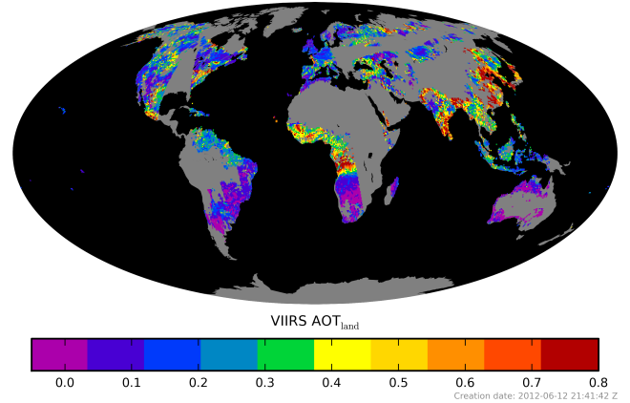 | 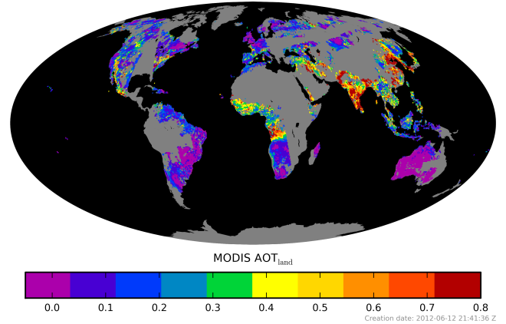
Figure 1.Global map of collocated VIIRS (left) and MODIS (right) AOT over land. (Note: The color bars are truncated at 0.8.)

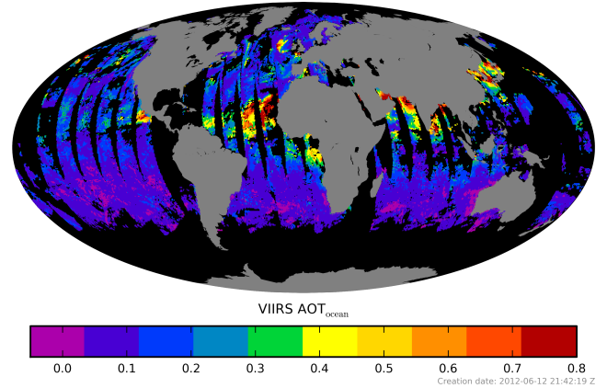 | 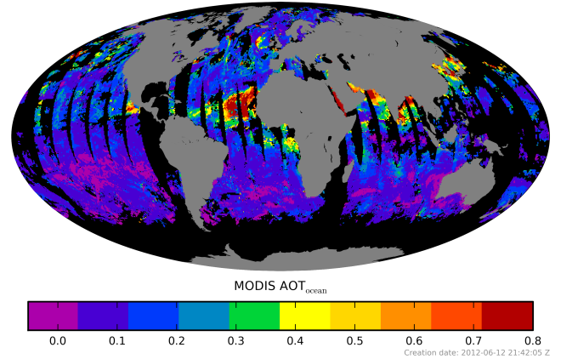
Figure 2. Global map of collocated VIIRS (left) and MODIS (right) AOT over ocean. (Note: The color bars are truncated at 0.8.)

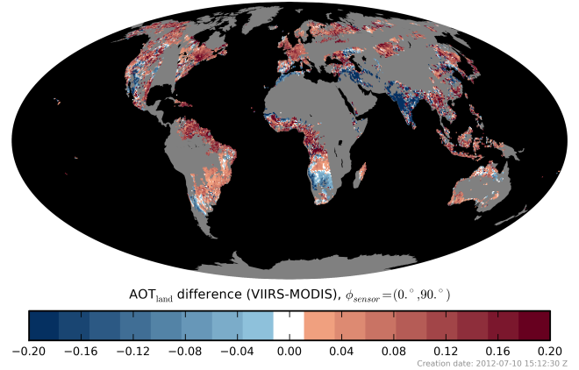 | 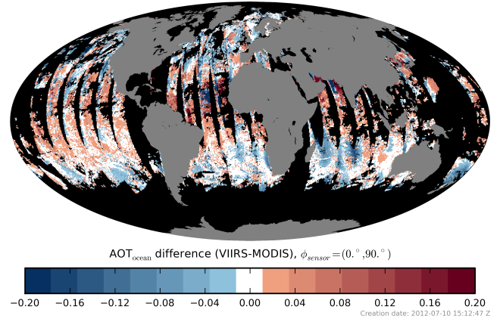
Figure 3. Global map of VIIRS AOT EDR difference (VIIRS-MODIS) over land (left) and ocean (right). Land and ocean are gray and black, respectively. AOT is plotted only for areas with collocated VIIRS and MODIS observations.
Scatter plots of VIIRS vs. MODIS AOT for the highest quality (QF=3) VIIRS EDR are shown in Figure 4.

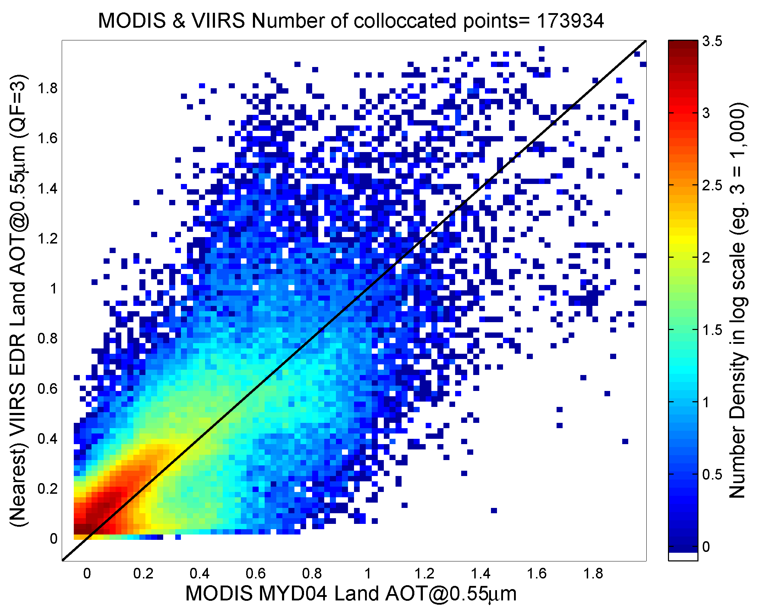 | 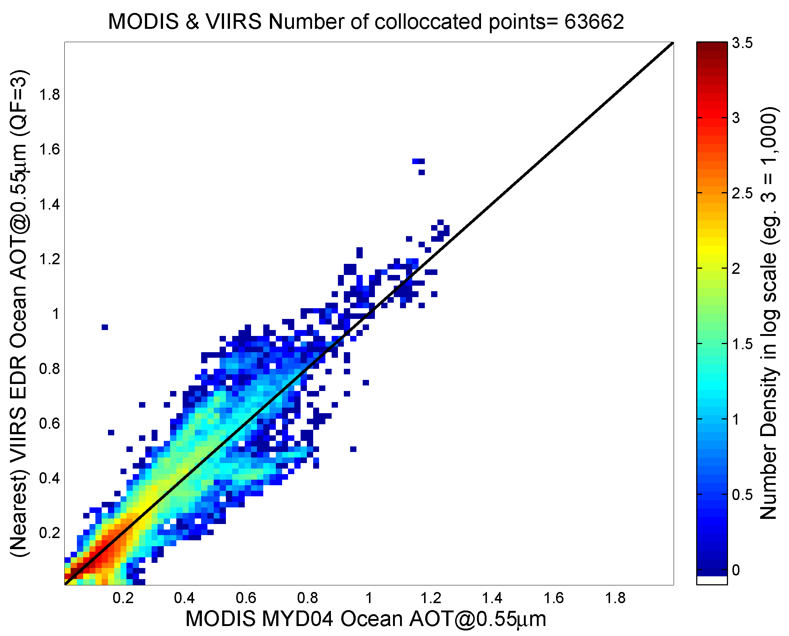
Figure 4. Scatter-density plot of VIIRS vs. MODIS aerosol EDR over land (left) and ocean (right). Only high quality (QF=3) VIIRS EDRs were used in the comparison. The solid line is the 1:1 line.

The VIIRS AOT over land product is clearly biased high against the MODIS product in a global sense. The high bias is regionally isolated to darker surfaces where aerosol is expected to be dominated by fine particles, either smoke or pollution. Over brighter surfaces, in desert transition zones where the MODIS product is known to be high biased against AERONET, VIIRS is actually biased low against MODIS. In this limited data set it is not known whether this low bias near deserts results from overestimation by MODIS or underestimation by VIIRS. The high bias in dark territory is obviously a VIIRS problem, as it appears in collocations with AERONET, as well.

Table 1. Statistics of VIIRS vs. MODIS AOT EDR differences from the direct-collocation comparison.
 | EDR AOT land | EDR AOT ocean
All QF | STD(ΔAOT) = 0.1657  Mean(ΔAOT) = 0.0310  R = 0.752  AOT_{VIIRS} = 0.7468 AOT_{MODIS} +0.0724 | STD(ΔAOT) = 0.0609  Mean(ΔAOT) = -0.0014  R = 0.9367  AOT_{VIIRS} = 0.9812 AOT_{MODIS} +0.0017
QF = 3 | STD(ΔAOT) = 0.1445  Mean(ΔAOT) = 0.0405  R = 0.8024  AOT_{VIIRS} = 0.7974 AOT_{MODIS} +0.0719 | STD(ΔAOT) = 0.0561  Mean(ΔAOT) = -0.0017  R = 0.9349  AOT_{VIIRS} = 0.9968 AOT_{MODIS} -0.0012
STD: standard deviation; R: correlation coefficient; ΔAOT: VIIRS-MODIS AOT difference.

Table 1 summarizes the results from the direct collocation comparison using all-quality data, as well as data filtered for high quality (QF=3). Table 1 also demonstrates that the bias and standard deviation of AOT differences increase when all-quality EDRs are used. Therefore it is recommended to use only high quality (QF=3) VIIRS retrievals as these compare better with MODIS. This is especially true over land, but not so important over ocean.
Filtering the high-quality VIIRS AOT entering the comparison over ocean with the APSP (Angstrom Exponent) EDR (APSP>1.6) further increases the agreement with MODIS. This suggests that over-ocean VIIRS AOT matches MODIS much better for fine mode dominated aerosol than for coarse mode aerosol. This partly could be due to MODIS cloud contamination, but also suggests VIIRS is having trouble with dust.

No collocation
In the comparison presented below all data are used from either source regardless of availability of corresponding data in the other source. (Details are given in Section 6.1.1.) These un-paired comparisons are useful as they may be indicative of the quality of the VIIRS aerosol products, relative to MODIS, in the absence of the MODIS product; that is they may give a hint on to what degree the VIIRS product can be considered as a continuation of the MODIS aerosol record. However, the interpretation of the results from these comparisons may not be straightforward since each product is affected by observation context issues that are independent of the retrieval used to obtain them. One of the most noticeable differences is the larger number of retrievals available from VIIRS due to its wider swath and smaller horizontal cell size. Another consequence of the larger swath size is the difference in the VIIRS and MODIS observation geometries for certain areas.
AOT patterns in the non-collocated data are similar but, compared to MODIS, VIIRS significantly overestimates AOT over land and underestimates AOT over dust outflow areas over ocean (Figure 5, and left panel of Figure 7). This global difference is persistent throughout the month studied (Figure 6). VIIRS provides ~5 times the number of samples over land than MODIS does and ~3 times over ocean (right panel of Figure 7). Some of these are due to the finer spatial resolution and broader swath width of VIIRS. However, spatial correlation exists between ratio of number of samples and difference between VIIRS and MODIS. VIIRS continues to retrieve in situations that MODIS chooses to avoid.

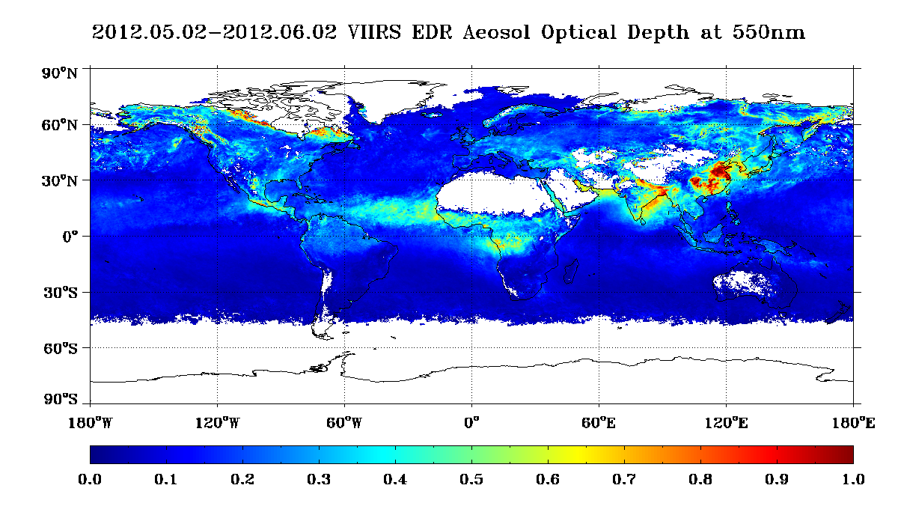 | 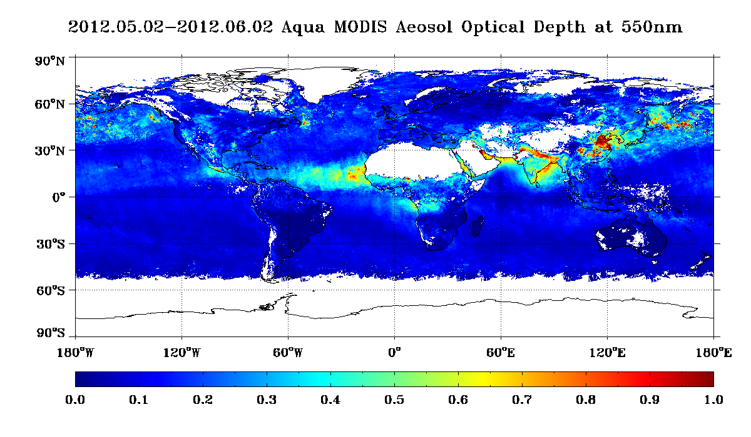
Figure 5. Monthly AOT EDR from VIIRS (left) and MODIS (right).
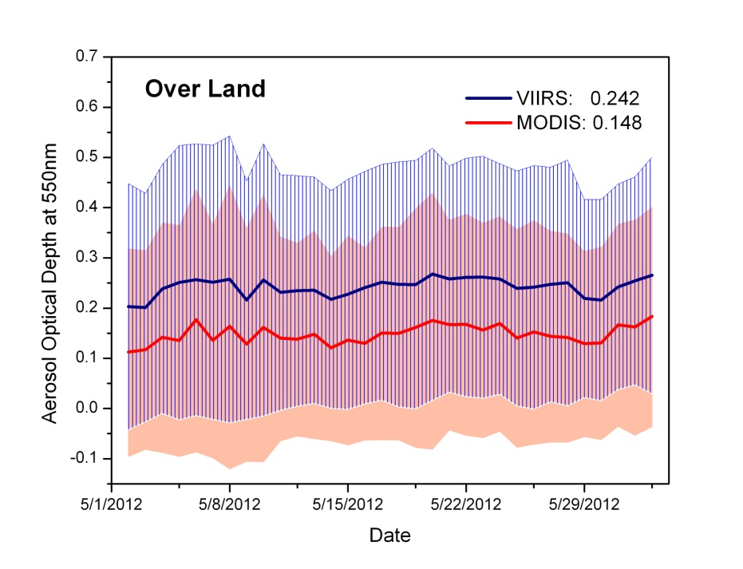 | 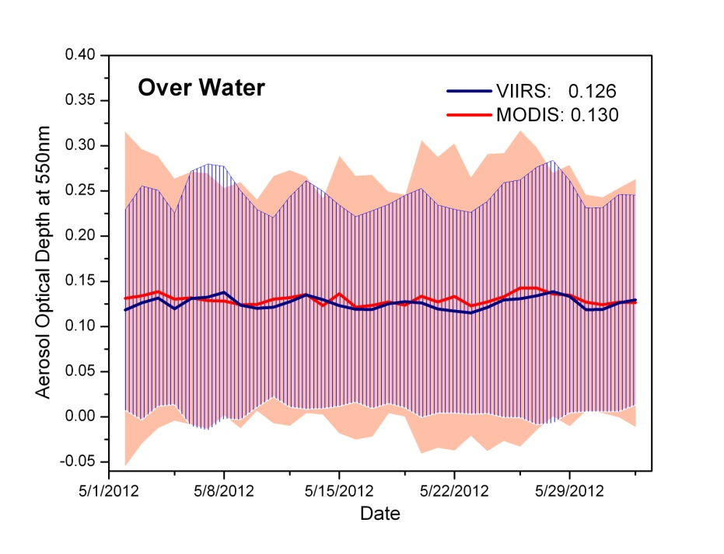
Figure 6. Time series of global VIIRS and MODIS AOT (solid line) and standard deviation (shaded area) for land (left) and water (right). Overall mean AOT is in top right corner.
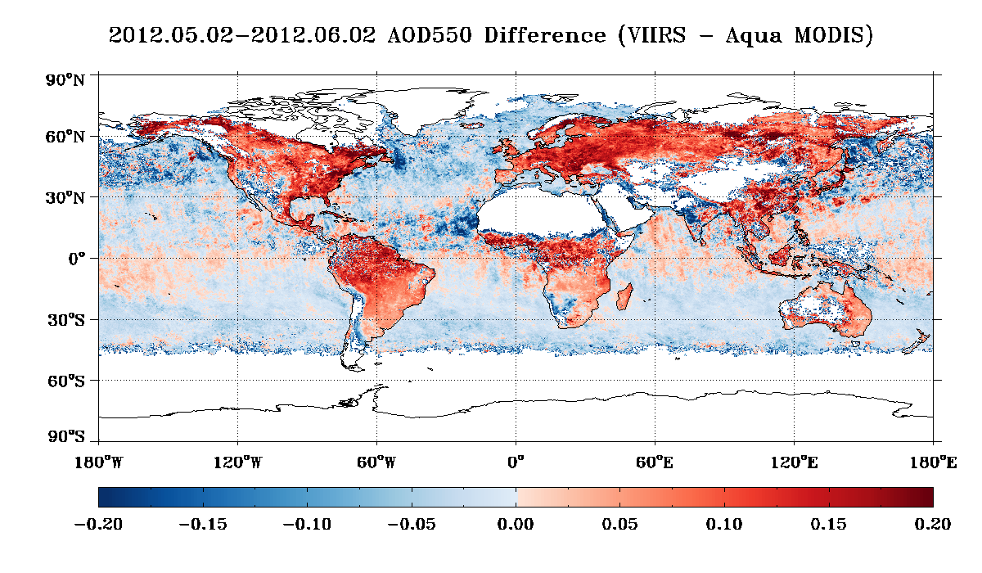 | 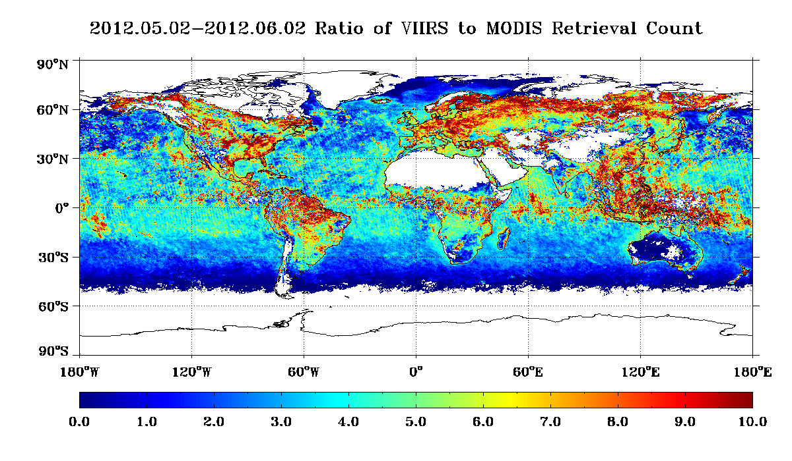
Figure 7. VIIRS-MODIS AOT difference (left), and ratio of number of VIIRS retrievals to number of MODIS retrievals (right) available for the study period.

Quality flags are extremely important for VIIRS. Differences between high quality and all quality for VIIRS are much larger than the same for MODIS.

VIIRS vs. AERONET
Over land, there are sufficient collocations with AERONET. Comparisons for the one month indicate VIIRS EDR is biased high by ~0.07 to 0.17 over land (Figure 8).
VIIRS vs. AERONET comparisons at coastal and island stations are problematic because VIIRS spatial averages around the AERONET station contain both land and ocean pixels and the exact point match-up is likely land, not ocean. Also there are insufficient collocations to draw strong conclusions. Despite these problems, it is clear that collocations with AERONET over ocean show high accuracy (~0 to 0.06) and precision (0 to 0.10) (Figure 9).
There is some similarity as to where VIIRS is biased high in both collocations (Figure 10). For example, high biases are observed over the Pacific NW, Eastern Europe, and Japan, But VIIRS is not biased high in the Amazon against AERONET.

 | 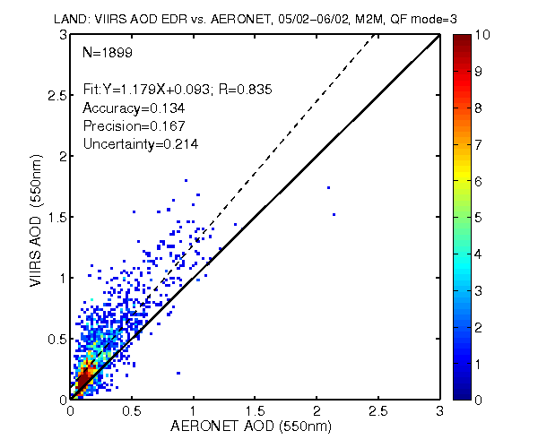 | 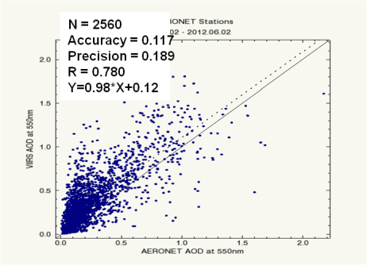
Figure 8. Scatter plot of Mean-to-Mean comparisons of VIIRS and AERONET AOT over land from Match-up 1 (left), Match-up 2 (middle) and Match-up 3 (right).
 | 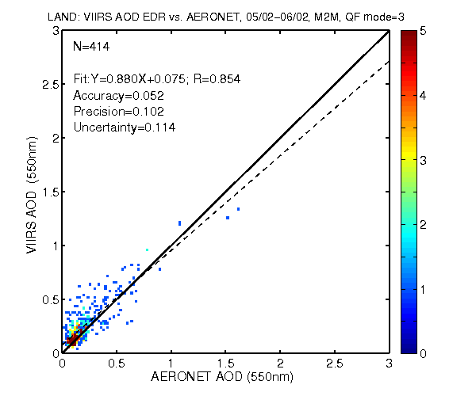 | 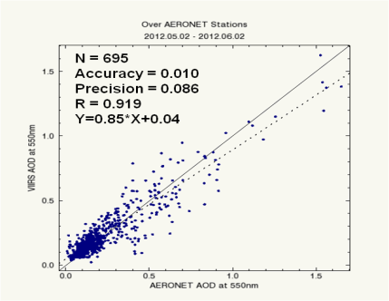
Figure 9. Scatter plot of Mean-to-Mean comparisons of VIIRS and AERONET AOT over ocean from Match-up 1 (left), Match-up 2 (middle) and Match-up 3 (right).

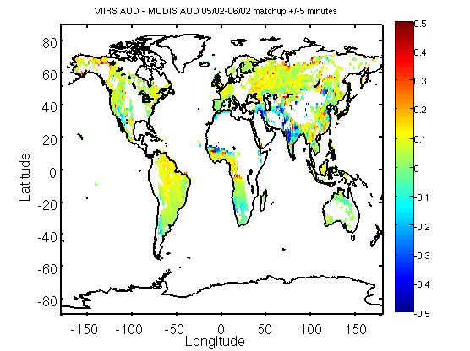 | 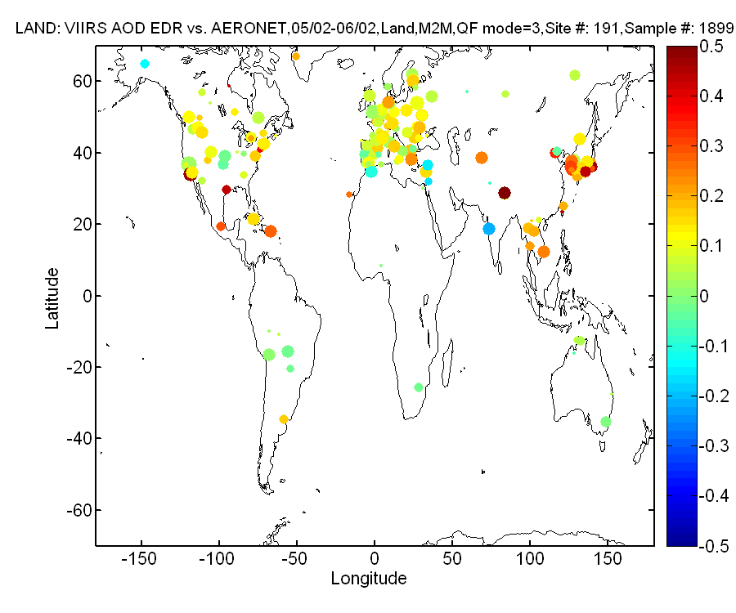
Figure 10. VIIRS-MODIS AOT difference (left) and VIIRS-AERONET difference (right).
Table 2. Accuracy, precision and uncertainty from VIIRS vs. AERONET matchups of AOT. Type of matchup, number of samples (N), and method (P/M: Mean-to-Mean: M2M, or Point-to-Point: P2P) are indicated.
LAND | P/M | N | Accuracy | Precision | Uncertainty
Match-up 1; IP | P2P | 157 | 0.204 | 0.319
 | M2M | 169 | 0.108 | 0.152
Match-up 1; EDR | P2P | 156 | 0.153 | 0.235
 | M2M | 202 | 0.073 | 0.134
Match-up 2; EDR | P2P | 1794 | 0.171 | 0.225 | 0.283
 | M2M | 1899 | 0.134 | 0.167 | 0.214
Match-up 3; EDR | M2M | 2560 | 0.117 | 0.189 | 0.222
OCEAN | P/M | N | Accuracy | Precision | Uncertainty
Match-up 1; IP | P2P | 1 | -0.003 | 0.000
 | M2M | 43 | 0.005 | 0.044
Match-up 1; EDR | P2P | 17 | -0.003 | 0.062
 | M2M | 55 | 0.003 | 0.042
Match-up 2; EDR | P2P | 188 | 0.008 | 0.069 | 0.069
 | M2M | 414 | 0.052 | 0.102 | 0.114
Match-up 3; EDR | M2M | 695 | 0.010 | 0.086 | 0.087

Table 2 summarizes the accuracy, precision and uncertainty statistics obtained from the comparisons of VIIRS AOT EDRs and IPs with AERONET AOTs. The statistics are presented for the different match-up methods (1, 2, and 3) and types (Mean-to-Mean and Point-to-Point).
Based on the above comparisons it appears that one standard deviation of VIIRS aerosol optical depth EDR products fall within ±0.09 ±10% of collocated MODIS retrievals over land and ±0.02 ±10% over ocean. The same VIIRS product falls within ±0.13 ±15% of collocated AERONET over land and ±0.04 ±5% over ocean.
The Aerosol Cal/Val Team recommends declaring Beta Maturity Level for the VIIRS AOT.
The evaluation for the Provisional Maturity level will increase the number of collocations over ocean by employing ship-borne aerosol optical depth measurements available from the Maritime Aerosol Network (MAN). Man is a component of AERONET. The reason for the high AOT bias observed over land and implementation of subpixel snow/ice mask similar to that used by MODIS to avoid issues with spring thaw will also be investigated.

APSP
Over ocean, it seems quality flags are more important for Angstrom Exponent than for AOT. The VIIRS APSP EDR (Angstrom Exponent) filtered with QF=3 correlates with MODIS, but biased high. Disagreement between VIIRS and MODIS Angstrom Exponents are much larger than APSP when all QFs are used (left panel of Figure 11).
The agreement between VIIRS and MODIS Angstrom Exponents over ocean can be increased by screening for AOT greater than 0.4 (identical to AERONET) (right panel of Figure 11). In this case the APSP bias is ±0.5. Screening only for AOT greater than 0.15 (as it is done now) produces results similar to using all AOTs.
IP-level APSP over ocean (even high quality) has little correlation with MODIS and is biased low, suggesting cloud contamination in the IP (not shown).

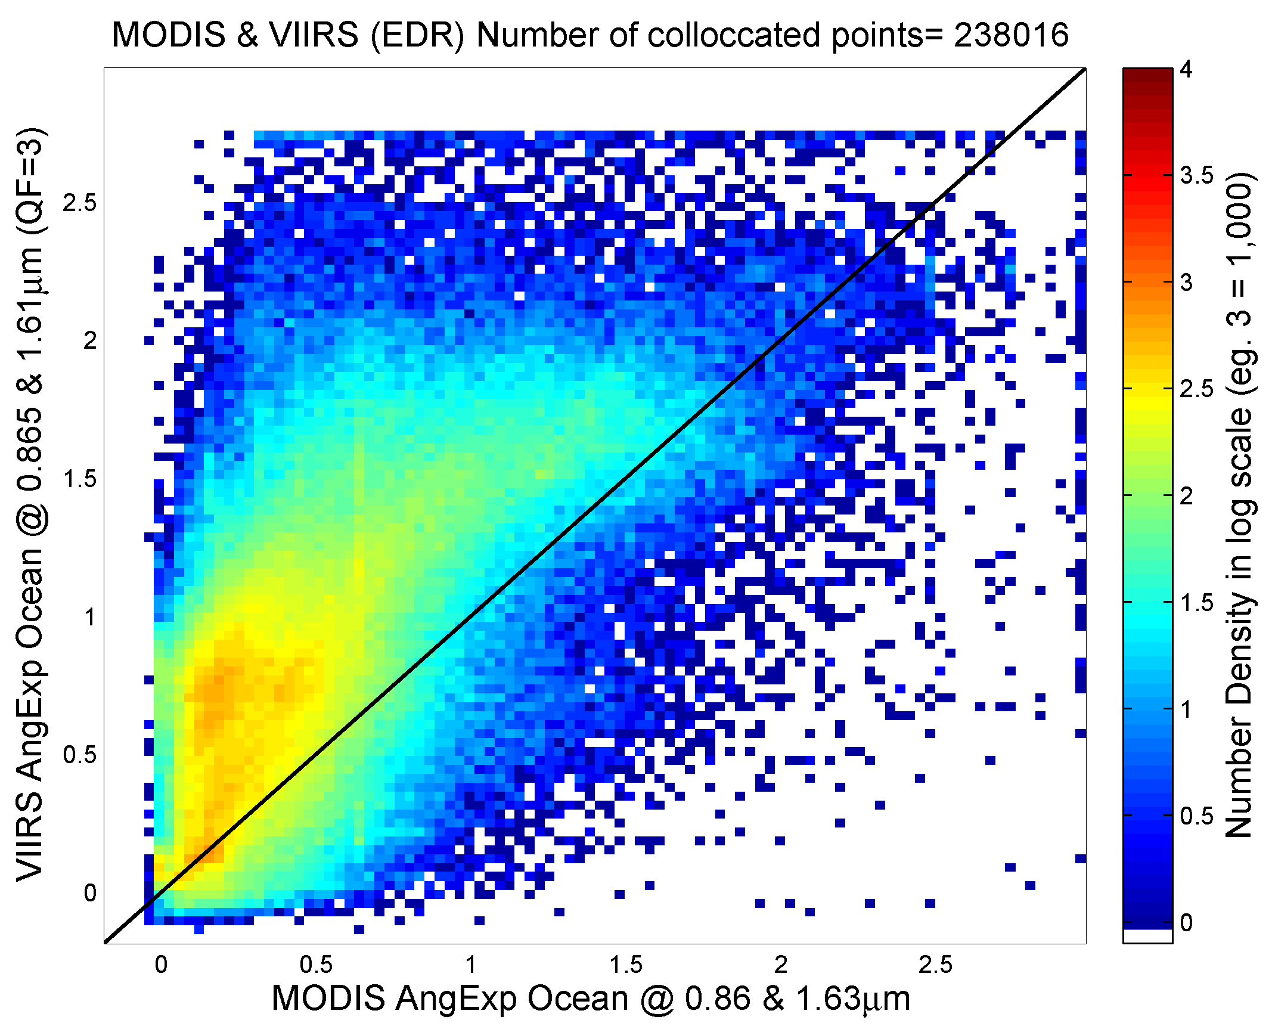 | 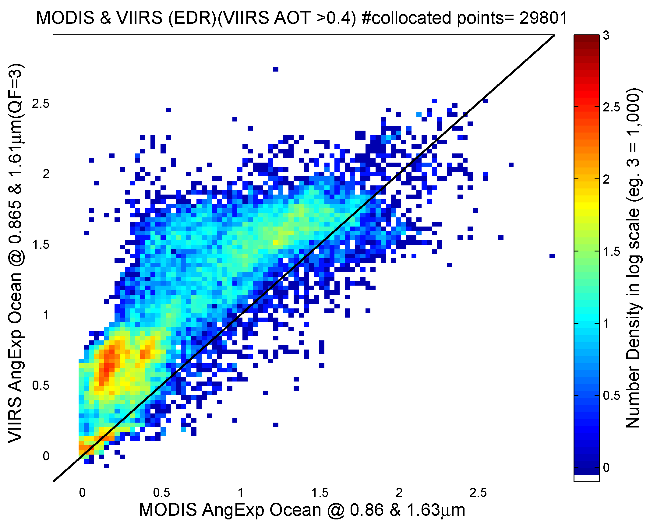
Figure 11. Left: Scatter plot of over ocean VIIRS Angstrom Exponent calculated from AOTs at 0.865 and 1.61 µm vs. MODIS Angstrom Exponent derived from AOTs at 0.86 and 1.63 µm. High quality (QF=3) APSP is used. Right: Same as on the left except only Angstrom Exponents corresponding to AOT>0.4 are used (disregard dot-dash line).

Over land, the Angstrom Exponent is completely uncorrelated with MODIS, but MODIS is completely uncorrelated with AERONET (Figure 12). The MODIS Land Angstrom Exponent is binary and not well-correlated with AERONET. MODIS cannot be used as a standard to evaluate the VIIRS for this product.

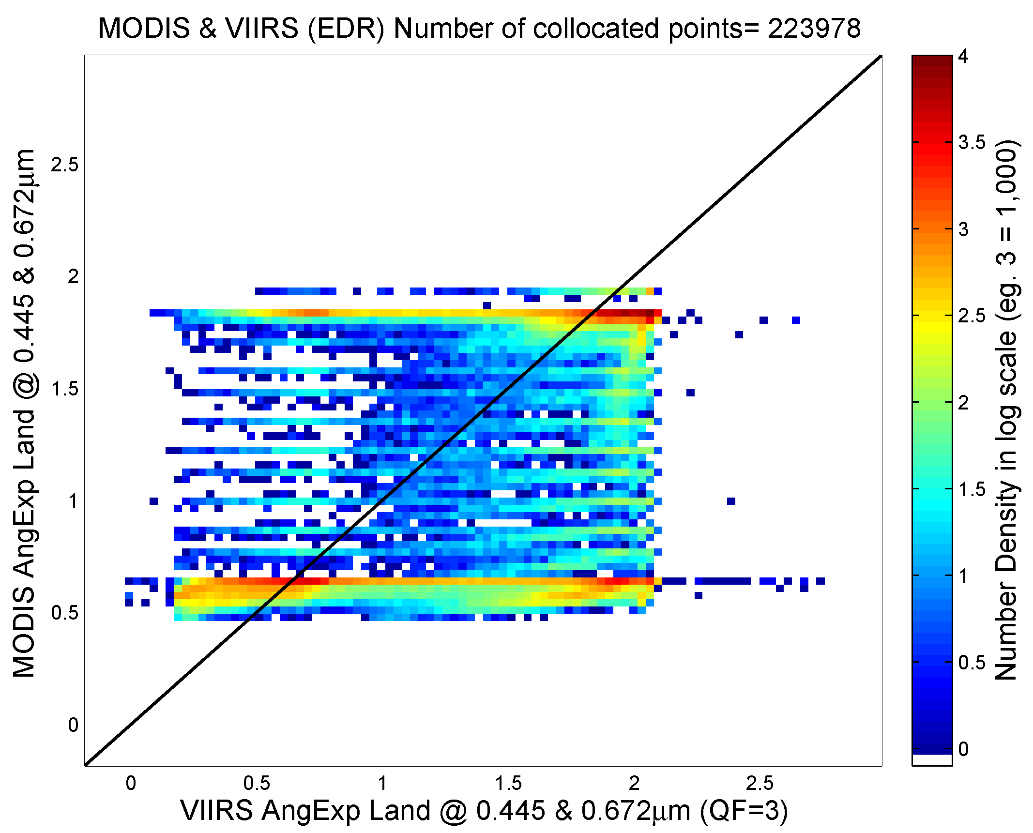 | 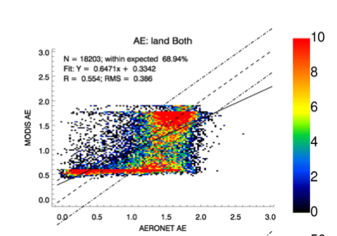
Figure 12. Left: Scatter plot of MODIS vs. VIIRS Angstrom Exponent over land calculated from AOTs at wavelengths 0.445 and 0.672 µm (the MODIS 0.466-µm AOT was interpolated to the VIIRS wavelength 0.445 µm). High quality (QF=3) APSP is used. Right: Comparison of MODIS over land Angstrom Exponent with that from AERONET from Levy et al. (2010).

Monthly maps of the Angstrom Exponents from non-collocated VIIRS and MODIS indicate a significant overestimate from VIIRS both over land and ocean, suggesting smaller particles globally (Figure 13). Note that the wavelengths used to calculate the VIIRS and MODIS Angstrom Exponents are slightly different. The VIIRS wavelengths over land are 0.45 and 0.67 µm, while the MODIS wavelengths are 0.47 and 0.67 µm. Over ocean, the VIIRS wavelengths are 0.86 and 1.61 µm, while the MODIS ones are 0.86 and 1.63 µm.

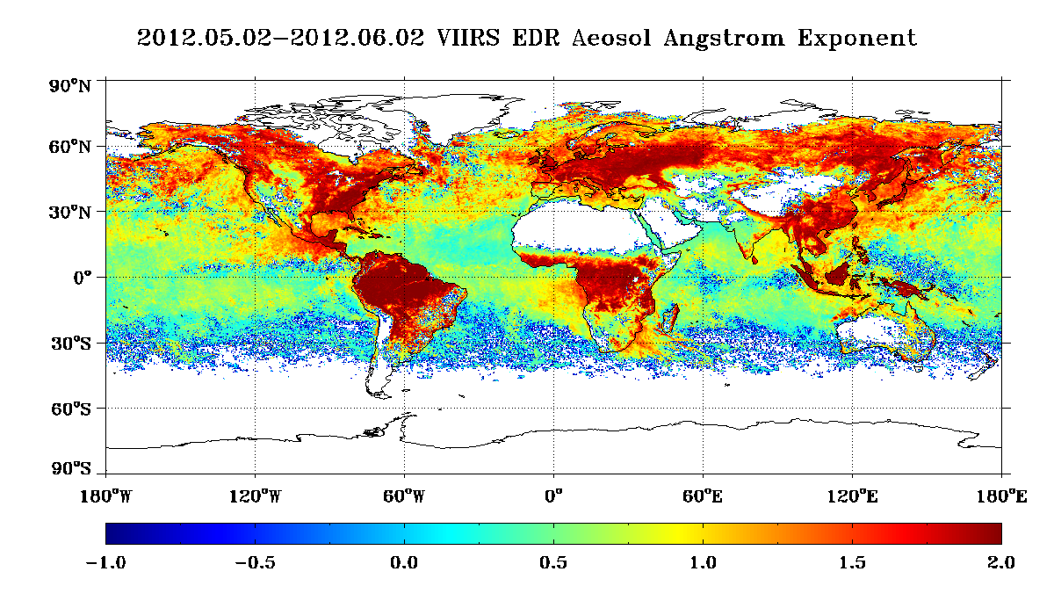 | 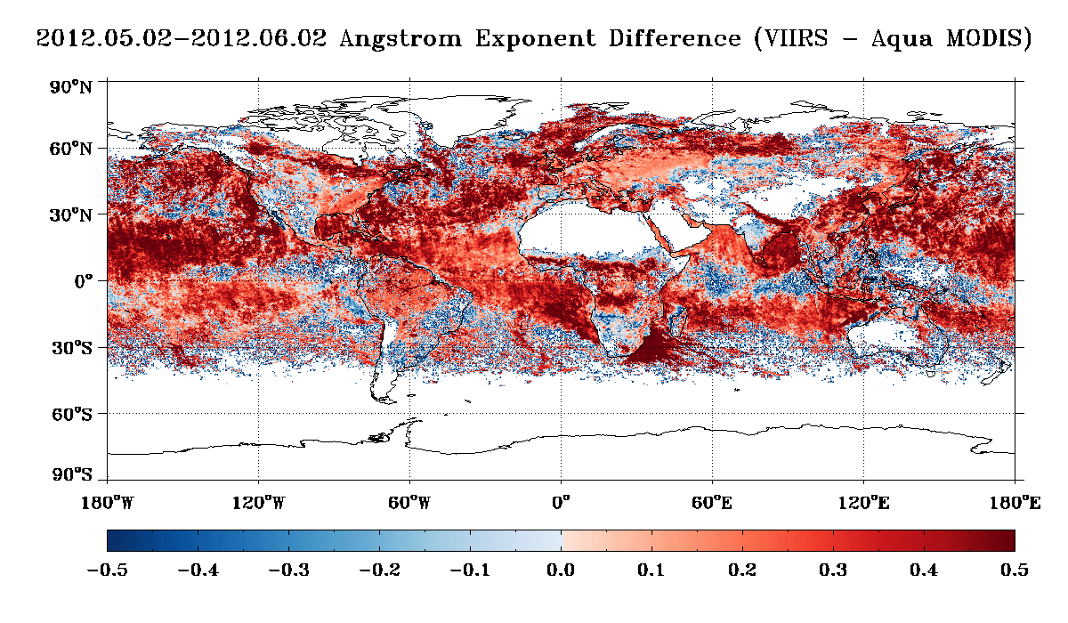
Figure 13. Maps of monthly mean VIIRS APSP EDR (left) and VIIRS-MODIS APSP difference (right) using non-collocated data.

Histograms of VIIRS and MODIS Angstrom Exponents suggest somewhat similar distributions over water. However, over land they are quite different; MODIS APSP shows a binary pattern corresponding to small (large particle) and large (small particle) values (Figure 14). Separate histograms are plotted for Angstrom Exponents with all-quality and best-quality. Again, as with AOT, the quality flag matters much more to VIIRS than to MODIS.

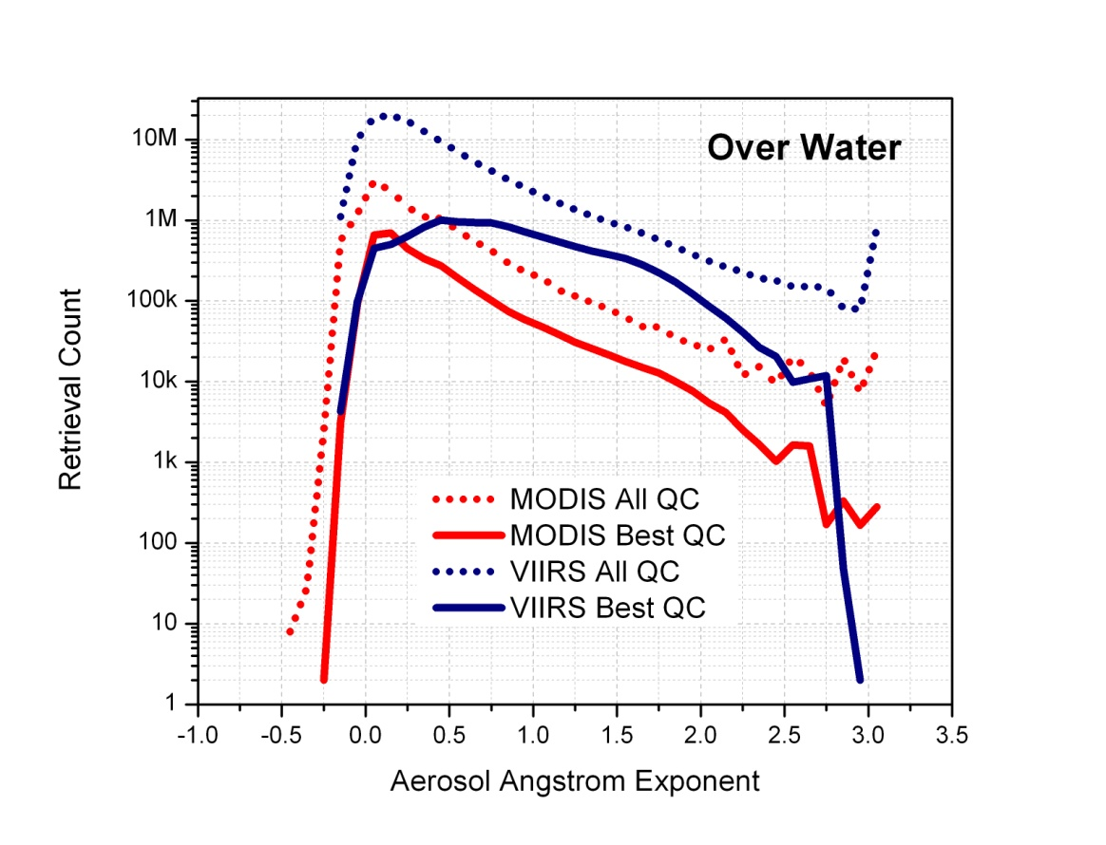 | 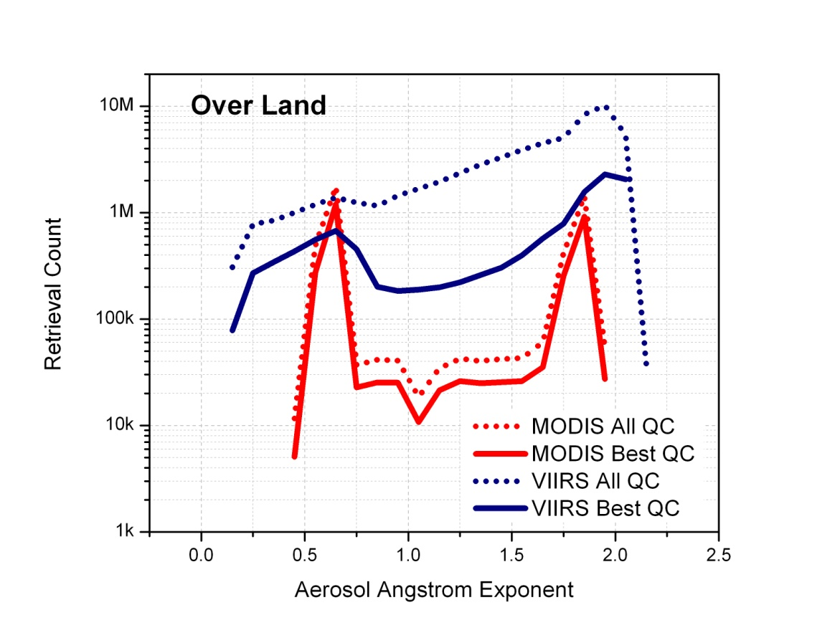
Figure 14. Histogram of VIIRS and MODIS Angstrom Exponents from non-collocated data over ocean (left_) and land (right). Angstrom Exponents with all-quality and best-quality are compared.

The comparison of VIIRS Angstrom Exponent EDR with that from AERONET over ocean (Figure 15) suggests that VIIRS will be biased high against AERONET, as it is biased high against MODIS. However, there is insufficient collocation over ocean to give firm support to this statement.

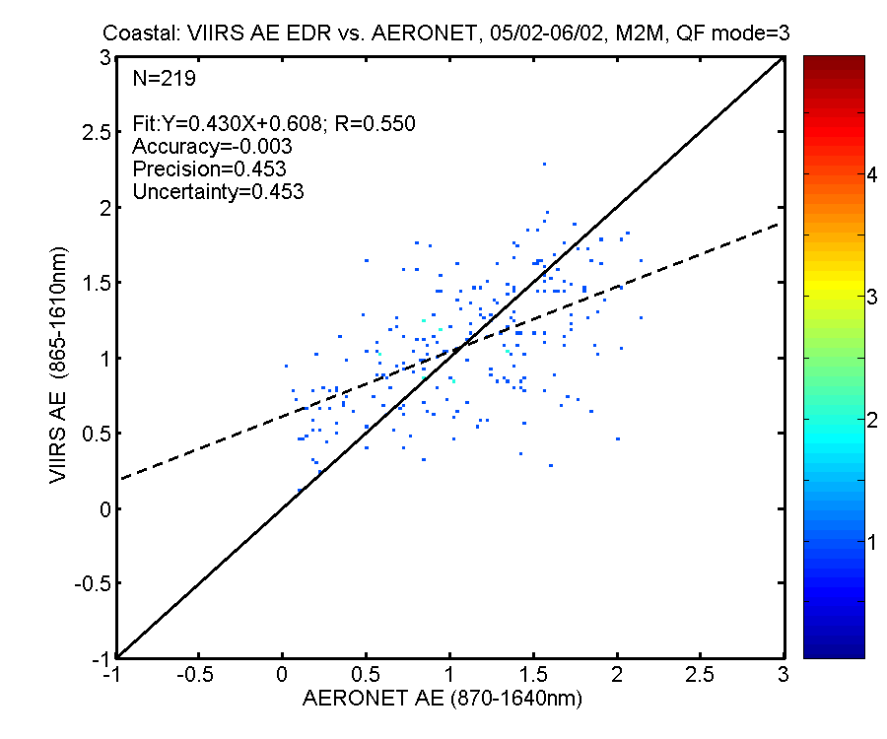
Figure 15. Scatter plot of VIIRS vs. AERONET (Truth) APSP (Alpha, AE) over ocean using Match-up 1 (left) and Match-up 2 (right). Both are Mean-to-Mean comparisons.

Over land, the same lack of correlation between VIIRS and AERONET as between VIIRS and MODIS is observed (Figure 16).

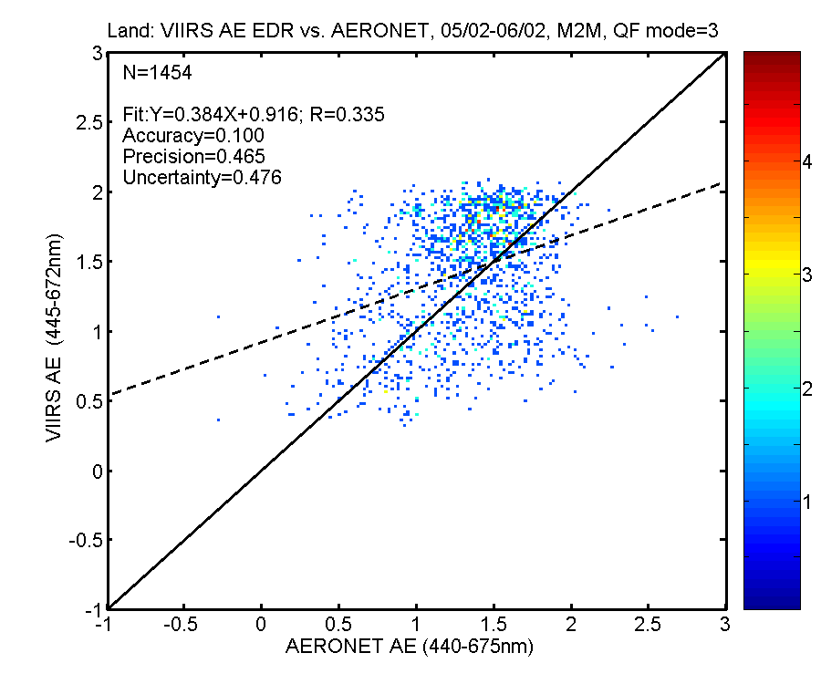
Figure 16. Scatter plot of VIIRS vs. AERONET (Truth) APSP (Alpha, AE) over land using Match-up 1 (left) and Match-up 2 (right). Both are Mean-to-Mean comparisons.

Table 3 summarizes the accuracy, precision and uncertainty statistics obtained from the comparisons of VIIRS APSP EDRs and IPs with AERONET APSP. The statistics are presented for the different match-up methods (1, 2, and 3) and types (Mean-to-Mean and Point-to-Point).

Table 3. Accuracy, precision and uncertainty from VIIRS vs. AERONET matchups of APSP. Type of matchup, number of samples (N), and method (P/M: Mean-to-Mean: M2M, or Point-to-Point: P2P) are indicated.
LAND | P/M | Sample Size N | Accuracy | Precision | Uncertainty
Match-up 1; IP | P2P | 94 | -0.286 | 0.778
 | M2M | 71 | 0.051 | 0.658
Match-up 1; EDR | P2P | 98 | -0.18 | 0.701
 | M2M | 117 | 0.021 | 0.649
Match-up 2; EDR | P2P | 1450 | -0.057 | 0.656 | 0.659
 | M2M | 1454 | 0.100 | 0.465 | 0.476
Match-up 3; EDR | M2M | 2241 | 0.042 | 0.602 | 0.603
OCEAN | P/M | Sample Size N | Accuracy | Precision | Uncertainty
Match-up 1; IP | P2P | 0
 | M2M | 17 | 0.097 | 0.358
Match-up 1; EDR | P2P | 10 | -0.103 | 0.455
 | M2M | 24 | 0.177 | 0.384
Match-up 2; EDR | P2P | 109 | -0.135 | 0.505 | 0.523
 | M2M | 219 | -0.003 | 0.453 | 0.453
Match-up 3; EDR | M2M | 189 | 0.086 | 0.715 | 0.718

The Aerosol Cal/Val Team recommends Beta Maturity level for EDR QF=3 over ocean Angstrom Exponent, only. In the assessment of the Team APSP over land is not at the Beta level. The Team further recommends using AOT > 0.4 to calculate the APSP EDR.
The evaluation for the Provisional Maturity level will increase the number of collocations over ocean by employing Angstrom Exponents calculated from ship-borne aerosol optical depth measurements available from the Maritime Aerosol Network (MAN). MAN is a component of AERONET. The reason for the high APSP bias observed over ocean and the possibility for any skill in APSP over land will also be investigated.

SM
A monthly map of the dominant high-quality suspended matter (ash, dust, smoke, sea salt, unknown, and none) is shown in Figure 17. Omnipresent volcanic ash is observed. This may be fixed either at the VCM level or by not accepting the VCM ash flag. Also, there is not enough dust over ocean. This may be fixed by relaxing the fine-mode-fraction (FMF) threshold. Too much smoke appears in the map. This could be remedied by renaming ‘smoke’ as ‘non-dust’.

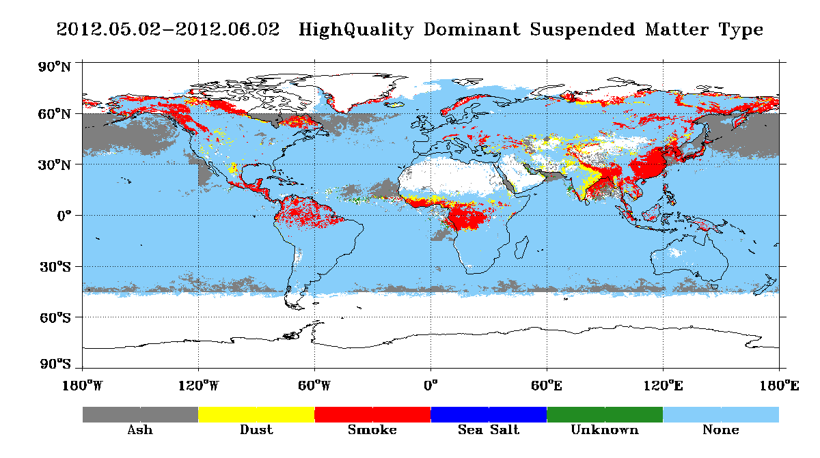
Figure 17. Monthly map of dominant high-quality gridded (0.25ºx0.25º) VIIRS SM.

The same is observed when monthly high-quality gridded (5ºx5º) VIIRS SM is compared to like parameters derived from CALIPSO. VIIRS reports much less dust than the CALIPSO plot suggests (Figure 18). Fractions of smoke from VIIRS and CALIPSO are also quite different (Figure 19).

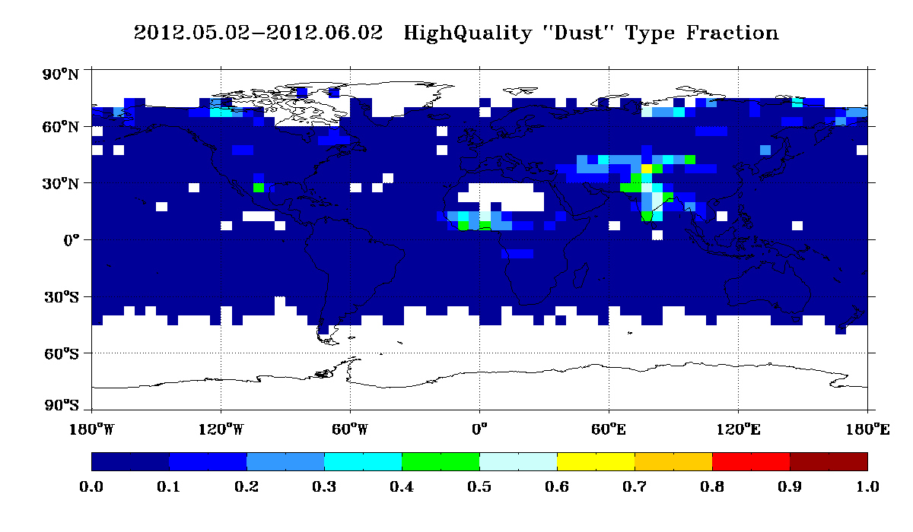 | 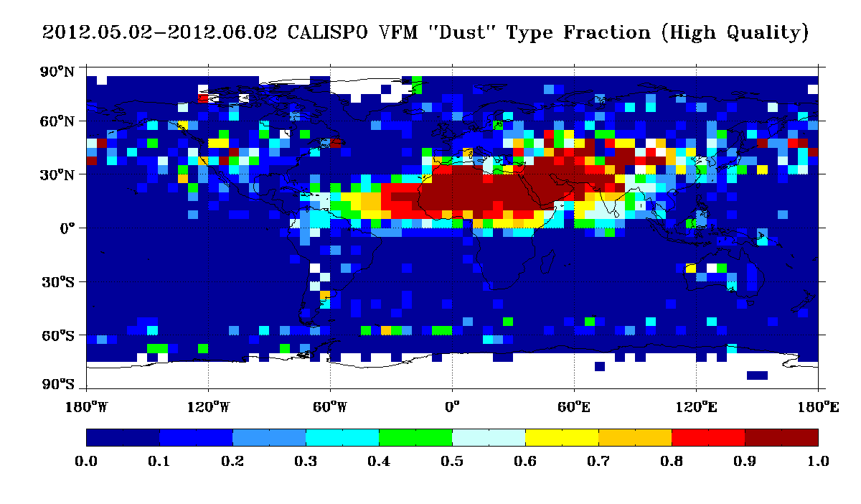
Figure 18. Monthly map of gridded (5ºx5º) VIIRS (left) and CALIPSO (right) dust fraction.

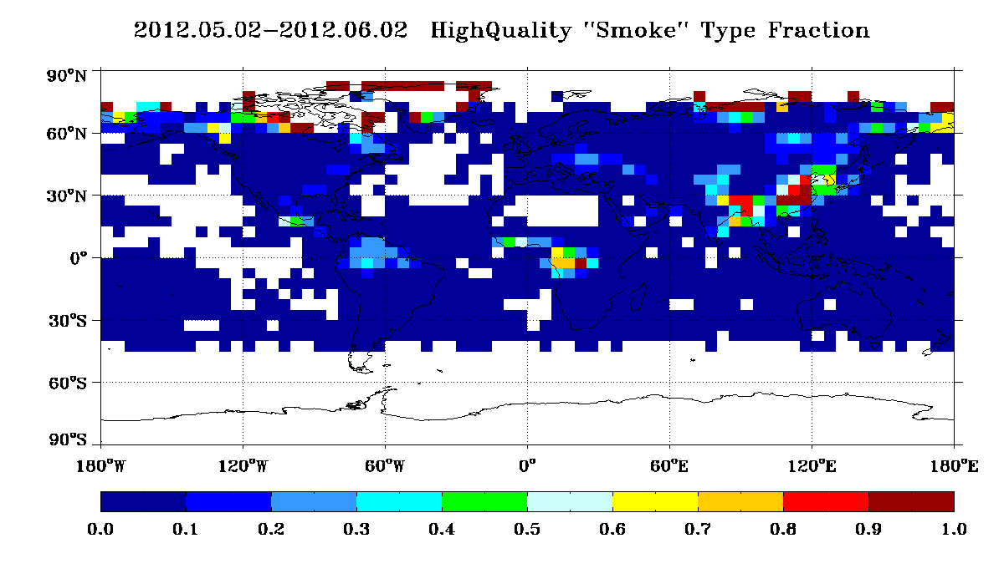 | 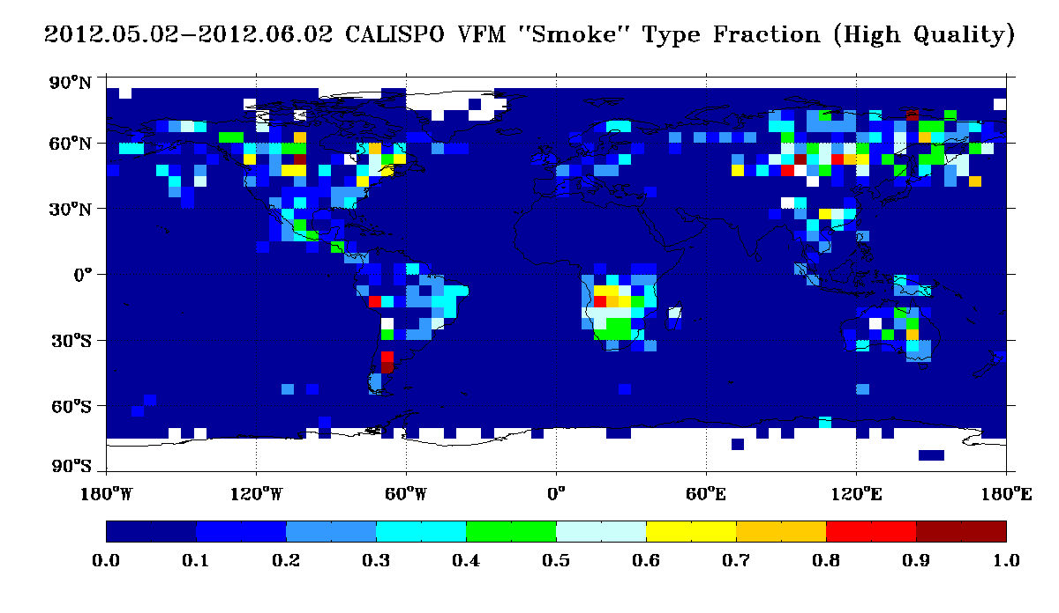
Figure 19. Monthly map of gridded (5ºx5º) VIIRS (left) and CALIPSO (right) smoke fraction.

In the assessment of the Aerosol Cal/Val Team the VIIRS SM product is not ready for the Beta Maturity level. Further analysis with data sets other than CALIPSO (e.g., MISR) is needed to overcome sampling issues.

The work for the Provisional Maturity level will include tuning thresholds to improve detection of dust over water and testing whether lowering the AOT threshold from 1.0 to 0.5 improves SM.

Related Documents
Suomi National Polar-Orbiting Partnership (NPP) Visible/Infrared Imager Radiometer Suite (VIIRS) Aerosol Products Users Guide, Version 1.0, July 2012.
Evaluation of the VIIRS aerosol EDR for Beta Maturity Level – extended results, PowerPoint slides containing the full set of results prepared for Beta Maturity.
Joint Polar Satellite System (JPSS) VIIRS Aerosol Optical Thickness (AOT) and Particle Size Parameter Algorithm Theoretical Basis Document (ATBD), Rev -, April 22, 2011.
Joint Polar Satellite System (JPSS) Operational Algorithm Description (OAD) Document for VIIRS Aerosol Products (AOT, APSP & SM) Intermediate Product (IP)/Environmental Data Records (EDR) Software, Rev A, January 18, 2012.

The Team’s original recommendation was not to declare APSP over ocean Beta. However, this was revised as a result of the Technical Interchange Meeting (TIM) on August 23, 2012.

