Supplementary Report to the NPP CrIS SDR Product BETA Review Summary
CrIS SDR Team

- Background
The CrIS SDR data product was reviewed on April 4th 2012 in Camp Springs Maryland. The purpose of the review meeting was to assess the readiness for declaring it as BETA maturity level by AERB. A total of 13 presentations were given during the meeting covering all aspects of the science, ground data processing, and utilization by the users. The review panel has approved the BETA maturity level proviso the accomplishment of 3 tasks: 1) Upload of the engineering packet version 33, 2) Upload of the new on-board FIR digital filter, 3) Verification of the IDPS CrIS SDRs produced after the 2 aforementioned uploads being consistent with the results presented in the review meeting. All the CrIS SDR review presentations have been achieved on Casanosa under: JPSS/DPA collaboration << Documents << CrIS SDR << STAR

The engineering packet version 33 (v33) and the new on-board FIR digital filter (DF) were successfully uploaded on April 11th and April 18th, respectively. Following the uploads, the team evaluated the IDPS CrIS SDR data and verified that the data quality and the improvements made by changing the engineering packet and the FIR filter are consistent with the results presented in the April 4th CrIS SDR product review meeting. This supplementary report summarized the verification results based on the presentations given in the telecon meeting on April 25th, 2012.
- Results
2.1 Comparisons between SDR data sets before and after Engineering packet version 33 upload
The updated parameters in v33 include Instrument Line Shape (ILS) parameters and nonlinearity coefficients (a2s) for Long-wave and Mid-wave band channels, as well as a minor change to the Internal Calibration Target (ICT) emissivity table. They were derived from the SDR data processed by the ADLs, G-ADA and science codes through manipulating the engineering packets embedded in the RDR data sets. The improvements made by the parameter adjustment were summarized in the 13 presentations given during the April 4th product review meeting. The SDR data sets for the verification work were obtained directly from the IDPS product. The verification results are included in the presentations in the accompanying package. Below is a summary and highlights of the results.
Figure 1 shows the differences of the observed Long-wave (LW) and Mid-wave (MW) band spectra from those simulated using the Community Radiative Transfer Model (CRTM), a key component of the NWP satellite data assimilation systems at the NOAA National Center for Environment Prediction (NCEP) and other NWP centers. The differences are computed with the equation, , where Obs and CRTM represents the observed and simulated spectra. One can see that the new results (the blue and red curves) obtained after v33 and the new DF uploads agree very well with the results (the black curves) presented in the April 4th product review meeting: the FOV-to-FOV non-uniformity caused by errors in the ILS and a2 parameters have largely reduced and the bias between the observations and the model simulations are also largely reduced. More results and descriptions are included in Presentation #1 (slides #3 and #4) and Presentation #2. The team is confident that the v33 has taken the expected effects in the IDPS CrIS SDR and the results and conclusions presented in the April 4th product review meeting are valid to the current IDPS CrIS SDR.

Figure 1. Relative biases between the observed and CRTM simulated LW and MW spectra. The observed spectra were from the SDR software with the new engineering packet (v33). The black curves are from the SDRs of March 29th generated by ADL, which were the results presented to the April 4th review meeting. The blue curves are from the IDPS SDRs of April 12th after the v33 upload but before the new DF upload, and the red curves are from the IDPS SDRs of April 19th after v33 and the new DF uploads. Each of the curves includes about 400000 observations.
2.2 Verification of striping bias elimination with the new FIR digital filter
Figure 2 shows the radiance differences between adjacent FORs as a function of FOR and time (left) and the radiance scan curves as a function FOR (right). From the radiance image on the left, one can clearly see the passage of the effect of the DF change which took place around 16.48 UTC on April 18th. The sweep direction bias (striping) caused by the defective DF is completed eliminated (see also plots on the right). This conclusion applies to all channels. More figures and results are included in Presentations #1 (slide 5), #3 (slides 2 – 14) and #4 (slides 3 and 4).
The result of complete elimination of the DF-caused striping is not expected at the time when the product review meeting was held, since the root cause of the striping problem was not discovered until after the meeting. Further investigation after the meeting found that two of the DF coefficients were corrupted. This finding led to an improved DF which eliminates the effect of the two corrupted coefficients.
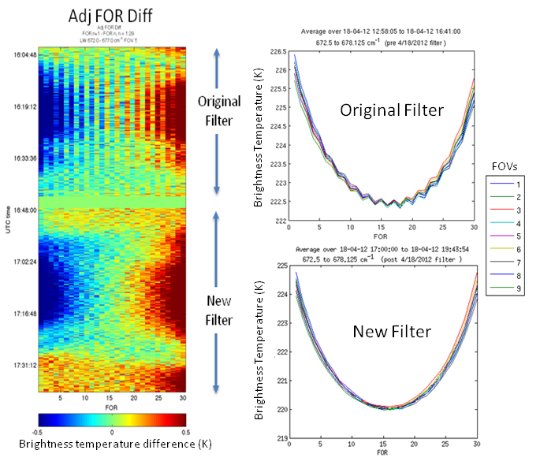
Figure 2. Brightness temperature differences between adjacent FORs as a function of FOR and time (left), and the brightness temperature as a function FOR (right). The radiance image (averaged over 672-677 cm⁻¹) on the left clearly shows the effect of the new filter after its upload at about 16.48 UTC on April 18th. The elimination of the striping bias can also be seen in the plots on the right.
- Conclusion and recommendation
Using the IDPS SDR data generated with the engineering packet version 33 and new FIR filter, the team has verified that the SDR data quality and the improvements made by the adjustment of the ILS and nonlinearity parameters and the digital filter change are consistent with the results presented in the April 4th product review meeting. Therefore, the team recommends AERB to declare the NPP CrIS SDR product a maturity level of Beta.
- Outstanding issues
The following issues remain, as reported to the Review Panel during the April 4th CrIS SDR product review meeting:
- The data quality flags (DQFs) are defective and the Beta product users shall not rely on them. These defective DQFs include SDR overall QF, Radiometric Calibration Invalid FQ, Spectral Calibration Invalid FQ, FCE Correction Failure FQ and FCE Detection Failure FQ. The DQFs are expected to be corrected for the PROVISIONAL maturity level review. The users are recommended to survey the imaginary part of the spectrum to assess the overall quality of the radiance. (The DQF issues are described in DR 4557, DR 4661 and DR 4478)
- The fringe count error (FCE) detection and correction code module has been found to be defective and has been disabled as part of the urgent code fix release MX5.3. Since the FCE is a rare event and the instrument is currently very stable, the lack of the FCE module currently does not pose a problem to the SDR data product. (DR 4481 and DR 4478)
- Monitored laser wavelength is set to value 0.0. (DR 4659)
- Some scans are incorrectly wrapped into granules whose time stamps don’t match. For example: the time different between the third and fourth scans wrapped in the following file SCRIS_npp_d20120412_t0143069_e0143447_b02365_c20120412080215203555_noaa_ops.h5 is about 16 seconds, not 8 seconds.

- List of accompanying presentations
- P1_STAR: Verification of IDPS CrIS SDR Beta Product with EngPkt v33 and New Digital Filter
- P2_NGAS: Analysis of Nonlinearity Correction for CrIS SDR – Comparisons Between V32 and v33 Engineering Packets
- P3_UW: Impact of New FIR Filter and IDPS/ADL Comparisons
- P4_LL: Comparison of Sweep Direction Errors with Old and New FIR Filters

