**Cross Track Infrared Sounder (CrIS) Sensor Data Record (SDR) Error Budget**

CrIS SDR Science Team

December 18, 2013

# Radiometric Calibration Accuracy

## Radiometric calibration uncertainty specification

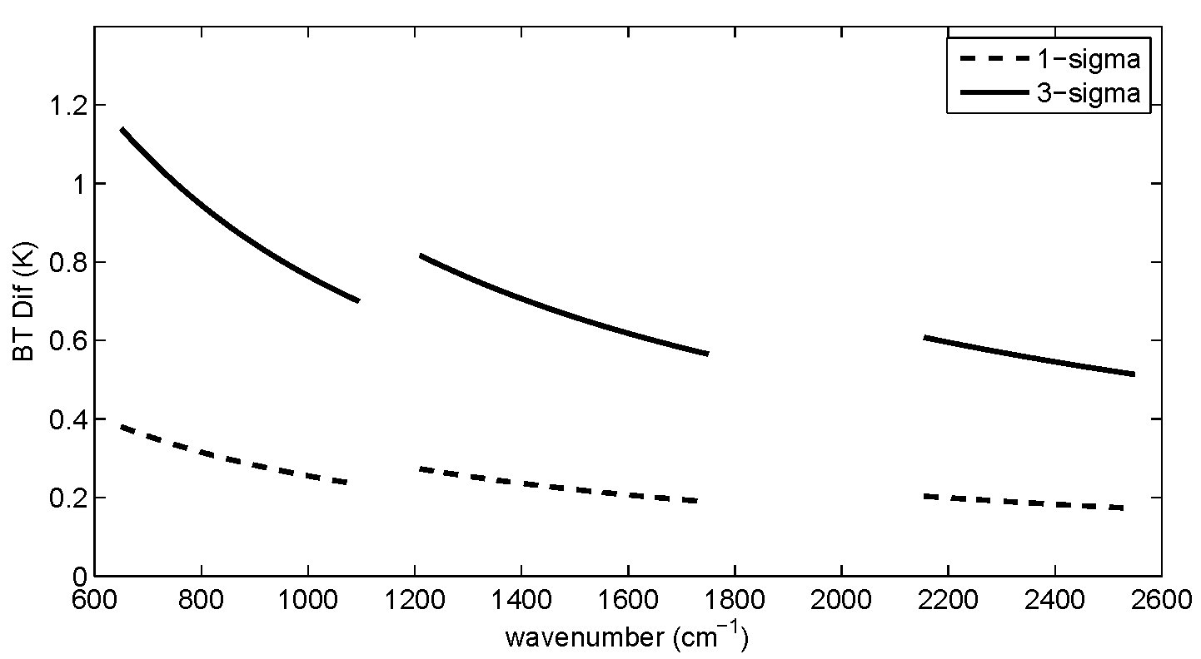

Figure 1. 1-sigma and 3 sigma Brightness Temperature (BT) uncertainty specifications, converted from1-sigma radiance uncertainties of 0.45%, 0.58% and 0.77% for the long-wave, mid-wave and short-wave bands respectively, when the instrument views a blackbody at temperature 287 K [Ref 1].

## Pre-launch radiometric uncertainty contributions

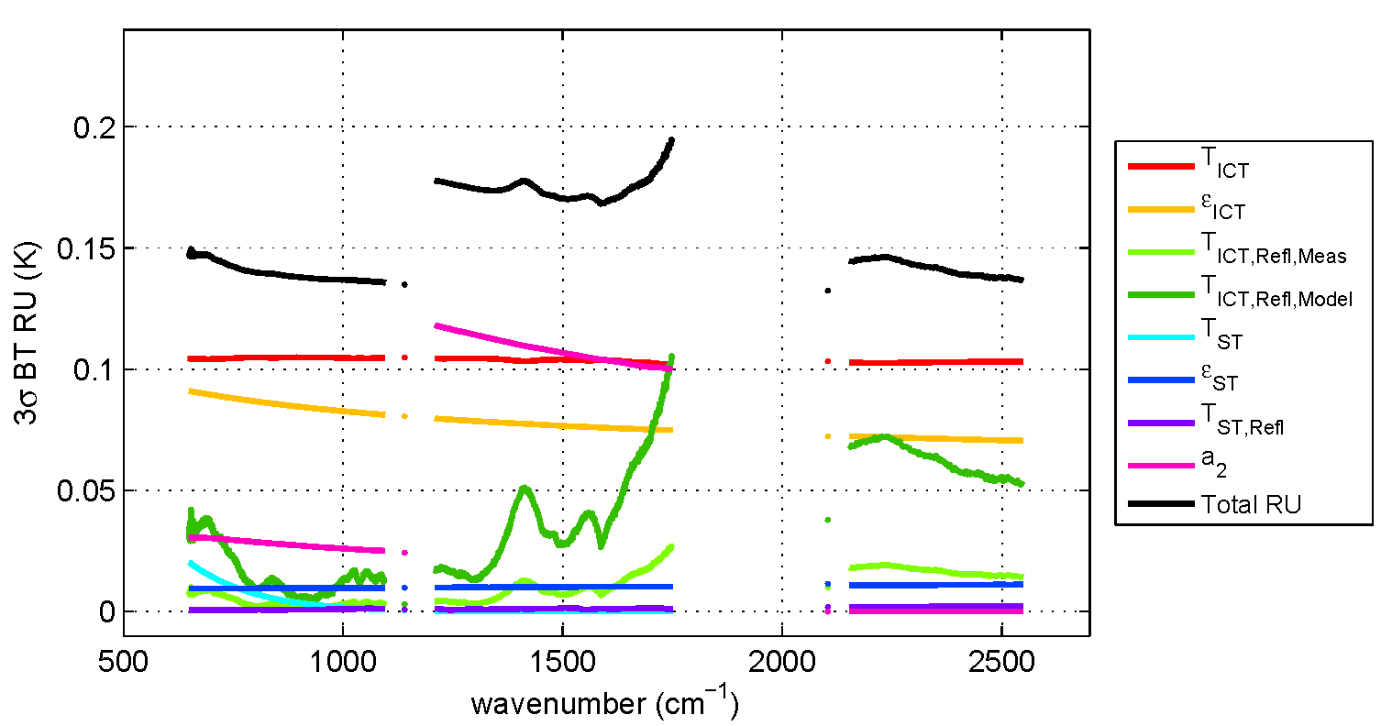

Figure 2. Pre-launch radiometric uncertainty (RU) contributions and total RU performance estimate for worst performing FOV at 287 K scene temperature [Ref. 1].

TICT – Internal Calibration Target (ICT) temperature

ICT - the effective cavity emissivity of the ICT

TICT, Refl, Measured and TICT, Refl, Modeled - effective temperatures of the reflected optical components which have temperature sensors and those whose temperatures require a thermal model

TST - the effective temperature of Space Target (ST)

ST - the ST effective emissivity

TST,Refl - the temperature of optical and structural components in view of the ST

a2 – Nonlinearity correction coefficient

## Post-launch radiometric uncertainty estimate

C:\Users\yhan\Documents\work\JPSS\CrIS_SDR\Presentations\JGR_papers\4papers\Tobin_figures\final_figures\figure08.eps

Figure 3. On-orbit 3-sigma RU estimates for a warm Earth view spectrum [Ref 1]. The legend for Figure 2 applies for the middle panel figures.

C:\Users\yhan\Documents\work\JPSS\CrIS_SDR\Presentations\JGR_papers\4papers\Tobin_figures\final_figures\figure09.eps

Figure 4. On-orbit 3-sigma RU estimates for a cold Earth view spectrum [Ref 1]. The legend for Figure 2 applies for the middle panel figures.

## Post-launch CrIS radiance comparisons with collocated sensors and radiative transfer model simulations

The differences between CrIS and various other observed or calculated brightness temperatures given in Table 1 are generally consistent with the high level of CrIS accuracy depicted in Section 1.3. However, these differences are just that, the differences of two sensor measurements (or obs-calc), and are not a direct indication that the absolute accuracy of either reaches these levels.

Table 1. Radiance difference between CrIS and AIRS/IASI/VIIRS, between observations and calculations computed using the radiative transfer models (RTM) SARTA and CRTM with collocated NWP atmospheric profiles and SST data, and between CrIS and Scanning HIS (S-HIS) [Ref 2; Ref 3].

|  |  |
| --- | --- |
| Comparison Source | Performance (CrIS – Comparison Source)  [range number] |
| AIRS | 672-682 cm-1: +0.06 to -0.06 K  830-840 cm-1: +0.00 to -0.18 K  1382-1408 cm-1: -0.03 to +0.12 K  1585-1600 cm-1: -0.32 to +0.15 K  2360-2370 cm-1: +0.98 to -0.07 K  2500-2520 cm-1: +2.86 to +0.09 K  from cold to warm scenes |
| IASI on MetOp-A | LW : -0.1-0.2 K (along wavenumber)  MW: -0.1-0.1 K (along wavenumber)  SW : 0.0-0.6K(along wavenumber) |
| IASI on MetOp-B | LW : 0.1-0.2 K (along wavenumber)  MW: -0.1-0.1 K (along wavenumber)  SW : 0.0-0.6K(along wavenumber) |
| VIIRS | VIIRS M13: 0.1-0.2K (all scenes)  VIIRS M15: 0.0-0.4K (from warm to cold scenes)  VIIRS M16: 0.01-0.1K (from warm to cold scenes) |
| RTM simulations | SARTA: -1.0-1.5K (along three bands)  -0.2 - -0.1 K (window channels)  CRTM: -1.0-1.5K (along three bands)  -0.2 - -0.1 K (window channels) |
| Aircraft instrument, S-HIS | LW: -0.2-0.2K (along wavenumber)\*\*  MW: 0.0-0.3K (along wavenumber)  SW: -0.0-0.2K (along wavenumber)  \*\* excluding spectral regions with significant  sensitivity above the aircraft altitude (20 km) |

# Spectral Calibration Accuracy

## Pre-launch spectral calibration error budget and Current Best Estimates (CBE) for worst performing FOVs

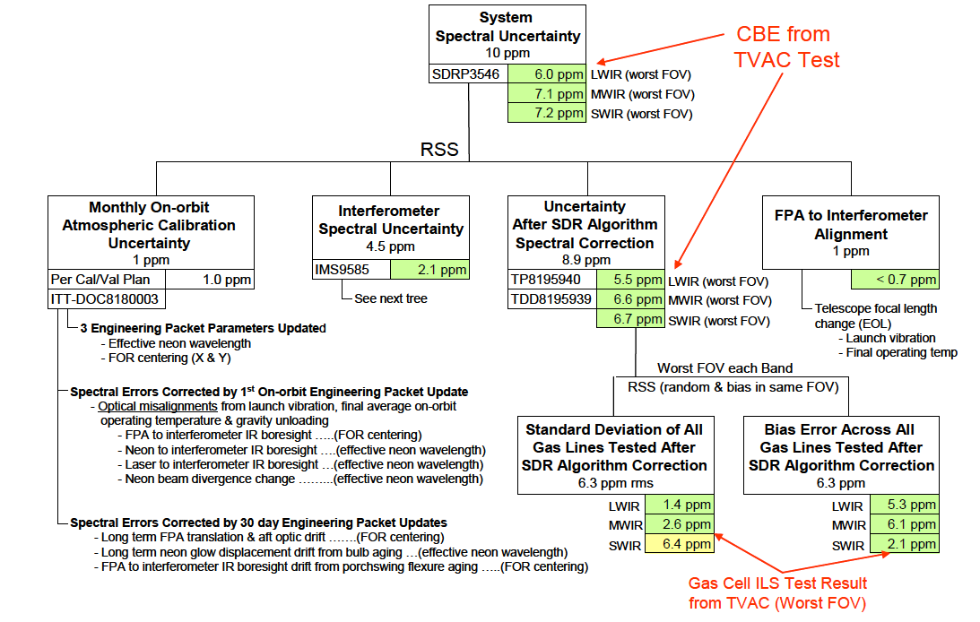

Figure 5. Pre-launch spectral calibration error budget tree and Current Best Estimates (CBE) of performance based upon TVAC testing [Ref. 4].

## Post-launch spectral calibration uncertainty estimates

Table 2. Relative spectral calibration uncertainty in ppm (relative to FOV5) [Ref. 5].

|  |  |  |  |  |  |  |  |  |  |
| --- | --- | --- | --- | --- | --- | --- | --- | --- | --- |
|  | FOV1 | FOV2 | FOV3 | FOV4 | FOV5 | FOV6 | FOV7 | FOV8 | FOV9 |
| LWIR | 0.03 | 0.03 | -0.01 | 0.03 | 0.0 | 0.12 | 0.20 | 0.15 | 0.15 |
| MWIR | -0.31 | 0.0 | -0.18 | -0.12 | 0.0 | 0.12 | -0.23 | 0.14 | 0.03 |
| SWIR | -0.68 | 0.10 | -0.08 | -0.41 | 0.0 | -0.64 | -0.06 | -0.04 | 0.27 |

Table 3. Long-wave band (LWIR) absolute spectral calibration uncertainty in ppm under the 2-ppm CMO rebuild condition, and the mid-wave (MWIR) and short-wave (SWIR) band spectral calibration uncertainties relative to the LWIR band (equivalent to that the spectral calibration assumes the CMO always follows the laser variation) [Ref 6]. Specification: 10 ppm for all the three bands.

|  |  |  |  |  |  |  |  |  |  |
| --- | --- | --- | --- | --- | --- | --- | --- | --- | --- |
|  | FOV1 | FOV2 | FOV3 | FOV4 | FOV5 | FOV6 | FOV7 | FOV8 | FOV9 |
| LWIR | < 3 | < 3 | < 3 | < 3 | < 3 | < 3 | < 3 | < 3 | < 3 |
| MWIR-LWIR | -1.44 | 0.03 | 0.68 | -0.64 | 0.42 | 1.72 | 0.0 | 0.71 | 1.52 |
| SWIR-LWIR | -1.25 | -1.35 | -0.76 | -1.37 | 0.07 | -0.1 | -0.02 | -0.82 | 0.34 |

# CrIS Geolocation

## Pre-launch mapping error budget

Figure 7. Pre-launch Current Best Estimate (CBE) of CrIS mapping error from ITT internal document [Ref 7].

## Post-launch geolocation accuracy estimate

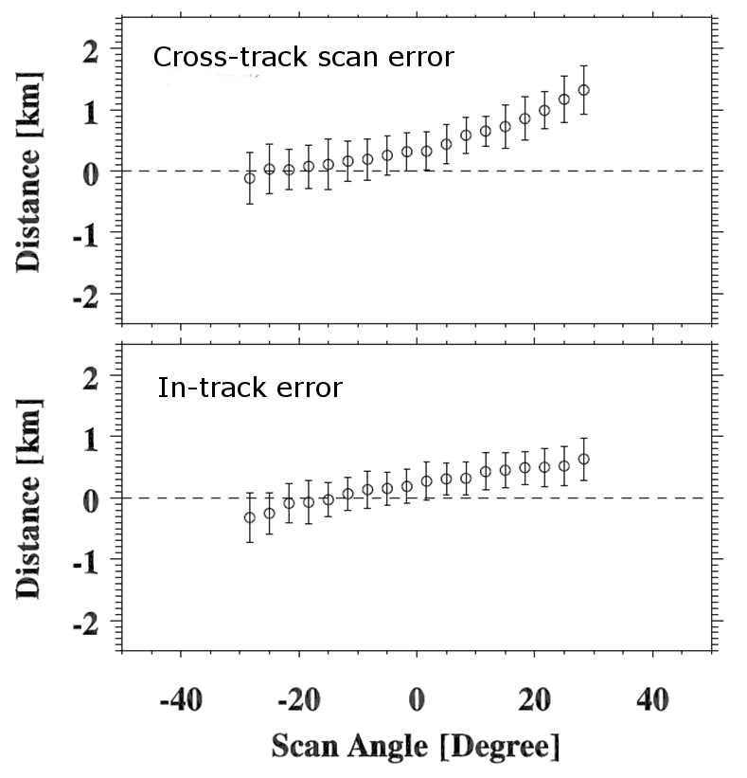

Figure 8. On-orbit CrIS geolocation accuracy as a function of cross-track scan angle, assessed with VIIRS channel I5. Geolocation accuracy beyond 30 degree scan angle cannot be determined with this method due to the bowtie deletion of VIIRS pixels. Geolocation accuracy specification: 1.5 km.

# Radiometric Noise (NEdN)

## Pre-launch NEdN

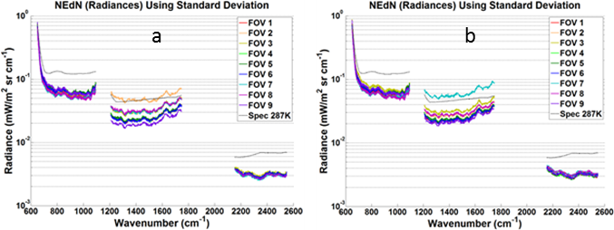

Figure 9. NEdN estimated during TVAC3 (a) and TVAC4 (b) tests at Mission Nominal conditions at the Environmental Calibration Target temperature TECT=287 K [Ref. 9].

## Post-launch NEdN

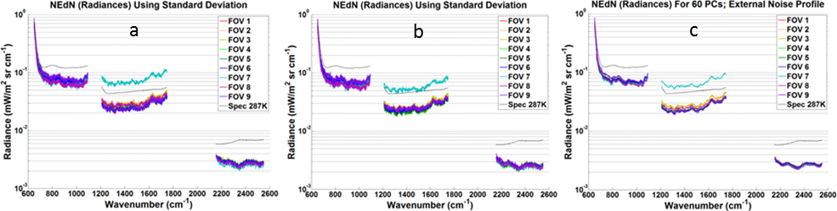

Figure 10. NEdN estimated from ICT (a), Deep Space (b), and Earth Scene (c) data acquired on 10 January 2013, Orbit 6245 [Ref. 9].

# References

1. Tobin, D., et al. (2013), Suomi-NPP CrIS radiometric calibration uncertainty, J. Geophys. Res. Atmos., 118, 10,589–10,600, doi:[10.1002/jgrd.50809](http://dx.doi.org/10.1002/jgrd.50809" \o "Link to external resource: 10.1002/jgrd.50809).
2. Tobin et al. (2013), Uncertainty Estimates and Evaluations, Presentation for the S-NPP SDR Science and Product Review meeting, December 18, 2013, College Park, MD 20720.
3. Wang Likun,  Yong Han, Denis Tremblay, Fuzhong Weng, Mitchell Goldberg (2012), Inter-comparison of NPP/CrIS radiances with VIIRS, AIRS, and IASI: a post-launch calibration assessment. Proc. SPIE 8528, Earth Observing Missions and Sensors: Development, Implementation, and Characterization II, 85280J (November 9, 2012); doi:10.1117/12.978769.
4. CrIS SDR Performance Definition, document date: 29 September 2010, Document number: D46843.
5. Strow, L. L, Howard Motteler1, Breno Imbiriba1, Chris Hepplewhite1, and Dave Tobin (2013), CrIS Spectral Calibration and Trending, Presentation for the S-NPP SDR Science and Product Review meeting, December 18, 2013, College Park, MD 20720.
6. Strow, L. L., H. Motteler, D. Tobin, H. Revercomb, S. Hannon, H. Buijs, J. Predina, L. Suwinski, and R. Glumb (2013), Spectral calibration and validation of the Cross‒track Infrared Sounder (CrIS) on the Suomi NPP satellite, J. Geophys. Res. Atmos., 118, doi:[10.1002/2013JD020480](http://dx.doi.org/10.1002/2013JD020480" \o "Link to external resource: 10.1002/2013JD020480).
7. ITT CrIS FM1 Sell-off Technical Memo, 8231529, Rev D, FOV mapping Uncertainty.
8. Wang, L., D. A. Tremblay, Y. Han, M. Esplin, D. E. Hagan, J. Predina, L. Suwinski, X. Jin, and Y. Chen (2013), Geolocation assessment for CrIS sensor data records, J. Geophys. Res. Atmos., 118, doi:[10.1002/2013JD020376](http://dx.doi.org/10.1002/2013JD020376).
9. Zavyalov, V., M. Esplin, D. Scott, B. Esplin, G. Bingham, E. Hoffman, C. Lietzke, J. Predina, R. Frain, L. Suwinski, Y. Han, C. Major, B. Graham, L. Phillips (2013), Noise performance of the CrIS instrument, J. Geophys. Res., doi: 10.1002/2013JD020457.