NPP VIIRS Flight 1 Relative Spectral Response (RSR) Overview

Contributors:

Chris Moeller (Univ. Wisconsin)
Tom Schwarting (NICST/Sigma Space Corp.)
Jeff McIntire (NICST/Sigma Space Corp.)
Hassan Oudrari (NASA/Sigma Space Corp.)
Dave Moyer (Aerospace Corp.)

May 2, 2011 (original document)
Revised: January 31, 2012
Table of Contents
Executive Summary 1
1. Introduction 2
2. RSR Measurement Background 2
3. RSR Products Overview 3
4. Observations 4
A. Government Team Instrument Level vs Spacecraft Level RSR 4
B. Northrop Grumman vs Government Team RSR 7
5. Recommendations 9
6. RSR Data Availability 10
7. Government Team Point of Contact List 10
Appendix A 11
Appendix B 13

Executive Summary

The NPP VIIRS RSR have been measured multiple times and independently analyzed by both the Northrop Grumman and Government teams. This document provides insight on the details of the RSR measurements and resulting RSR products. Northrop Grumman’s October 2011 band averaged RSR have been deemed acceptable by the Government team to represent the NPP VIIRS at-launch RSR. The Government team RSR, an alternative high quality RSR available to the science community, agree closely but not exactly with the Northrop Grumman RSR primarily due to analysis differences that only affect the RSR at low response levels. As the official at-launch RSR used to populate at-launch SDR and EDR LUTs, the Government team is recommending that the community apply Northrop Grumman’s October 2011 band averaged RSR product to support SDR and EDR product algorithm development and evaluation. However, the Government team RSR will remain available to the community for their investigative interests, and may evolve if new understanding of VIIRS spectral performance is revealed in the post-launch era of NPP.

Introduction
Spectral testing of the NPP VIIRS F1 sensor to retrieve relative spectral response (RSR) has taken place at two independent levels in the F1 pre-launch test program: instrument level and spacecraft level. Instrument level RSR measurements of all VIIRS spectral bands took place at the Raytheon El Segundo, CA facility in summer 2009, while spacecraft level RSR measurements of VisNIR bands took place at the Ball Aerospace (BATC) Boulder, CO facility in spring 2010. The instrument and spacecraft level RSR measurements are considered to be independent measurements, taken under very different test setup conditions of the F1 spectral performance. This document is intended to distinguish between these two sets of measurements as well as clarify Government team and industry versions of the RSR for the user community.

RSR Measurement Background
The RSR for the complete set of VIIRS bands was carefully measured during instrument level testing at Raytheon El Segundo in summer 2009. The Spectral Measurement Assembly (SpMA) was used with a slit reticle to constrain source illumination (1st order) to the detectors of a single band. Within the performance constraints of the SpMA dual monochromator system, such a measurement is ideal for identifying bandpass filter spectral characteristics for an illuminated band. However, analysis of data from other instrument level tests showed that VisNIR bands were affected by optical and electronic cross talk, effects that are not governed by the bandpass filter of a cross talk receiving band. It has been postulated that light traveling through the bandpass filters scatters at high angles, allowing out-of-band (OOB) light to reach the detectors of non-illuminated neighboring bands as well as the detectors of the illuminated band. Further, it was observed that the OOB signal contained dependence on source polarization and that indeed the dual monochromator SpMA is a highly polarized source in VisNIR wavelengths.

Motivated by the need to understand spectral performance and testing issues of the VisNIR bands, a set of special spectral measurements was sought and added to the spacecraft level test program conducted in Boulder, CO at BATC. Spacecraft level spectral measurements used a different strategy designed to complement and enhance the instrument level spectral testing of the VisNIR bands. To support these measurements, the Traveling SIRCUS (T-SIRCUS) laser based system was deployed by the National Institute of Standards and Technology (NIST) to the BATC test facility in spring 2010. With T-SIRCUS, the test was designed to illuminate the entire VisNIR focal plane simultaneously and uniformly by passing the source signal through a spherical integrating sphere. Through this strategy, all influencing effects including optical and electronic cross talk and high angle scatter contribution to OOB would be integrated into a single measurement in a “test as you fly” approach. The T-SIRCUS system had the further advantage that the source is unpolarized, removing a degree of freedom from the spacecraft level RSR analysis.

RSR Products Overview
The NPP VIIRS RSR measurements have been analyzed by industry (Northrop Grumman, henceforth “NG”) and by the Government team (NASA, Aerospace Corp., MIT/LL), resulting in multiple versions of NPP VIIRS RSR. The purpose of the NG RSR has always been to populate the Look-Up-Tables (LUTs) that support VIIRS SDR and EDR product processing at IDPS, whereas the Government team RSR had the following objectives:
- To provide an independent high quality analysis of RSR, available for comparing with the NG RSR product.
- To release an early pre-launch high quality RSR data set to the science community preparing for the launch of NPP.

NG released RSR in March 2010, December 2010 and again in October 2011. The October 2011 release is considered to be the best NG RSR product. The NG RSR, which include both a detector based and a band averaged RSR, consist of the following:
- An “effective” RSR (combination of polarization corrected instrument level RSR and cross talk influence measurements from other instrument level testing) for bands I1 and I2.
- A “fused” RSR (combination of instrument level “effective” RSR and spacecraft level RSR measurements) for bands M1 – M7. This includes cross talk influence.
- A RSR based upon instrument level measurements for bands M8 - M16(A,B) and I3 - I5. This does not include any cross talk influence.

The Government team RSR, a detector based RSR product, currently consist of:
- RSR for bands M1 – M7, I1 and I2 based on instrument level RSR measurements and referred to as the Government Team “Best” RSR for F1 VisNIR Bands (September 2010 release). This does not include cross talk influence.
- RSR for bands M8 – M16(A,B) and I3 – I5 based on instrument level RSR measurements and referred to as the Government Team “Best” RSR for F1 CFPA Bands (September 2010 release). This does not include cross talk influence.
- RSR for bands M1 – M7 based on spacecraft level RSR measurements and referred to as the Government Team “Best” Spacecraft-Level RSR for F1 VisNIR M-Bands (April 2011 release). This includes cross talk influence.
- RSR for bands I1, I2 based on spacecraft level RSR measurements and referred to as the Government Team “Best” Spacecraft-Level RSR for F1 VisNIR I-Bands (June 2011 release). This includes cross talk influence.
- RSR for Day-Night Band (DNB) based on instrument level RSR measurements and referred to as the Government Team “Best” RSR for F1 DNB (November 2011 release).

After a detailed review by the Government team, the October 2011 band averaged NG RSR product release has been deemed appropriate to represent the NPP VIIRS at-launch RSR characterization. The Government team has recommended that the October 2011 NG band averaged RSR product be used to populate the Look-Up-Tables (LUTs) that support VIIRS SDR and EDR product processing at IDPS.
As can be seen in Section 4.B and in Appendix B, comparisons between the NG band averaged at-launch RSR and the Government team RSR products show close but not exact agreement. With a few exceptions, differences are confined to low response (<1E-04) wavelengths. As such the Government team RSR data set represents a high quality alternative RSR data set available to the community for their research interests, while the NG RSR represents the official at-launch RSR. The Government team RSR product will remain available to the science community to support investigation of RSR influence on SDR and EDR products as the understanding of VIIRS performance evolves and matures through the NPP mission lifetime. The Government team RSR product may also be updated to reflect any new insight and understanding gained in the post-launch NPP era.

Observations
This section will provide some insight on the various Government team and NG RSR products by providing some example comparisons. Sub-section A provides some insight on differences in the RSR as depicted at instrument level and spacecraft level in the Government team RSR products; perhaps of greater interest to potential users of the RSR products, sub-section B compares NG and Government team RSR products.

A. Government Team Instrument Level vs. Spacecraft Level RSR
Bands M1 – M7, I1, and I2 were measured at both the instrument level and the spacecraft level. As outlined in section 2, there were important differences in the test design and source characteristics of the instrument level and spacecraft level measurements. Therefore, it was not expected that instrument level and spacecraft level RSR would (nor should) exactly agree; the degree to which these two RSR data sets do not agree provides insight on cross talk and polarization influence in VIIRS RSR. Additionally, the spacecraft level RSR test setup is generally accepted as superior to the instrument level RSR test setup for scaling OOB and cross talk influence to the in-band response, due largely to the absolute source characterization that was collected and applied in the spacecraft level analysis.

Figure 1 shows the resulting RSR from Government team analysis of both sets of measurements for one detector of band M1. The following is evident in Figure 1:
- Most of the peaks in the OOB region are reflected in both the instrument level and spacecraft level measurements.
- Spacecraft level RSR contain a response zone centered at about 550 nm that is not shown in instrument level RSR. This is a cross talk feature.
- There are small amplitude differences in the common response peaks of the two data sets, likely due to test setup differences and/or polarization and cross talk influences on the RSR.
- Spectral coverage of instrument level measurements extends beyond the coverage of spacecraft level measurements.
- Portions of the spacecraft level data appear noisy at much higher response levels than the instrument level data.

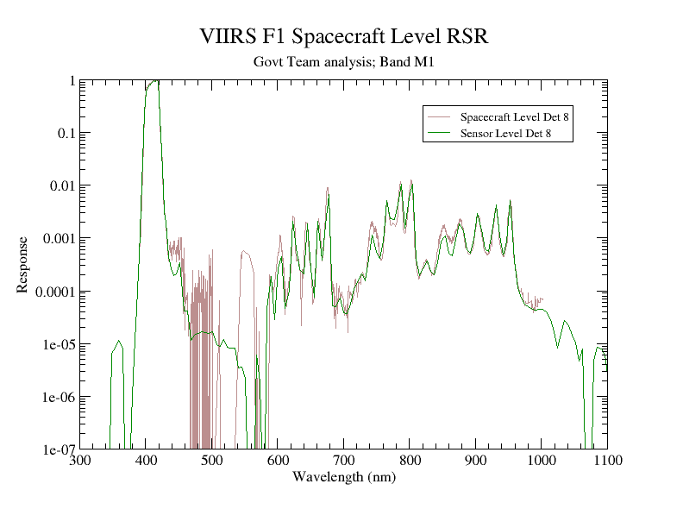
Figure 1. Comparison of band M1 instrument and spacecraft level RSR for detector 8.

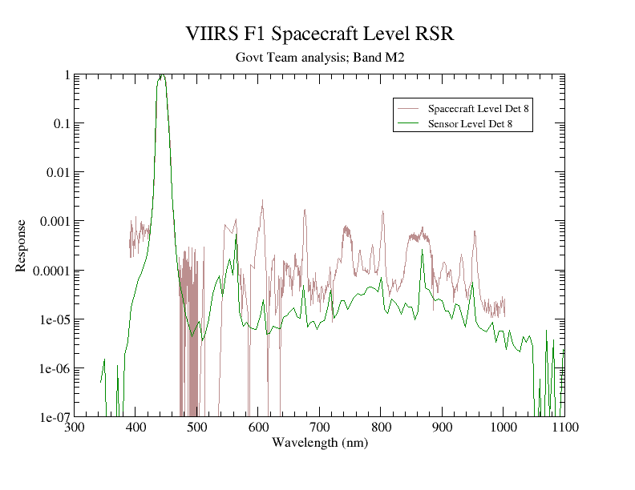
Figure 2. Comparison of band M2 instrument and spacecraft level RSR for detector 8.

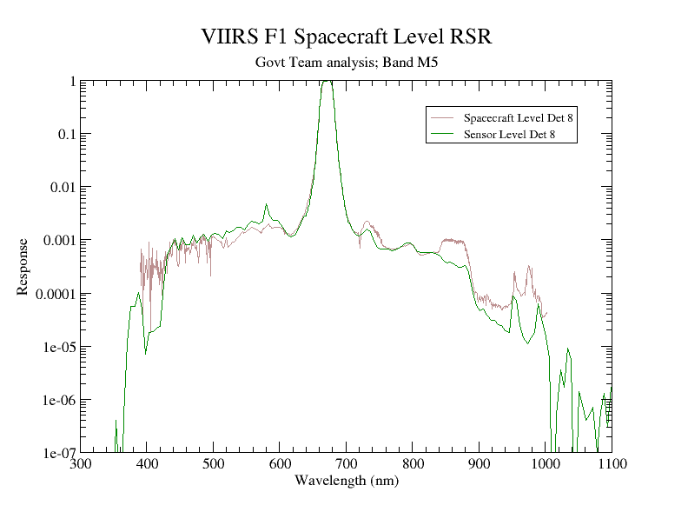
Figure 3. Comparison of band M5 instrument and spacecraft level RSR for detector 8.

Response peaks in the M1 OOB region are largely believed to be due to high angle scattering in the filter of the illuminated band. Figure 1 largely supports that hypothesis through close agreement in the amplitude of OOB peaks for both instrument level
and spacecraft level RSR. Exceptions are evident in the M4 (~540-560nm), M6 (~740-750nm), and M7 (~840-880nm) spectral regions where cross talk driven response is also
occurring in the spacecraft level RSR; because M4, M6, and M7 detectors are not illuminated during M1 instrument level spectral testing, no cross talk response is present from those spectral regions in instrument level M1 RSR. Spacecraft level data is clearly noisy in the 430-500nm spectral region.

By contrast, M2 (Figure 2) shows considerable amplitude difference between the instrument level and spacecraft level RSR. Other instrument level testing has indicated that these differences are largely due to optical cross talk from M1 and M4 into M2. This optical cross talk is captured in the M2 spacecraft level RSR. Electronic cross talk driven response at the spectral positions of bands M4, M6, and M7 is also evident in M2 spacecraft level RSR, superimposed on optical cross talk and OOB driven response. Points 4 and 5 from band M1 discussion are also relevant to band M2.

Figure 3 shows the M5 band RSR. In this case there is relatively close agreement between the instrument level and spacecraft level RSR at most wavelengths. The M5 RSR contains a broad high response plateau from 430-620nm that has been attributed to colored glass fluorescence (also found in bands M4, M6, and M7 in Appendix A). It is noteworthy that the spacecraft level RSR is unable to depict the response drop-off from the fluorescence shoulder at about 430nm due to the higher noise present in the spacecraft level measurements. Electronic cross talk driven response is also evident in the spacecraft level RSR at the M6 (~740-750nm) and M7 (~840-880nm) spectral positions. A considerable response difference in the 960-1000nm region is not well understood, perhaps driven by polarization influence in the instrument level RSR.
Figures showing the comparison between instrument level and spacecraft level RSR for bands M3, M4, M6, and M7 are present in the appendix of this document. Their behavior is consistent with that of the bands discussed in this sub-section.

B. Northrop Grumman vs. Government Team RSR
The at-launch RSR for NPP VIIRS is a band averaged RSR, released by NG in Oct 2011. NG applied an SNR based filter and detector dispersion test to discriminate low quality from high quality response, identifying wavelength limits for each band outside of which the response is filtered. This comprises the at-launch RSR data set currently available to the community on the NOAA JPSS web site (http://www.star.nesdis.noaa.gov/jpss/).

While NG incorporated many aspects of the Government team RSR analysis into their RSR, some differences remain with the Government team RSR. The NG RSR are based upon instrument and spacecraft level measurements (i.e. “fused” RSR) for bands M1 - M7 and upon instrument level measurements alone for bands I1 - I5 and M8 - M16(A,B). For comparison purposes, the Government team produced its own version of a fused RSR for detector 8 of bands M1 – M7. Like the NG fused RSR, the Government team fused RSR retained all high quality spacecraft level response and supplemented that with instrument level response to fill in spectral gaps; unlike the NG fused RSR, the Government team did not normalize the instrument level and spacecraft level RSR to each other before creating the fused RSR, nor did the Government team apply a crosstalk or polarization correction to the supplemental instrument level response (these corrections considered to be small at low response). This will result in some differences between the NG and Government team RSR at low response wavelengths in the OOB portion of the RSR. Additionally, the Government team analysis retained the noise floor response in its RSR products whereas NG filtered out the noise floor for its RSR product.

Examples of the spectral comparison between NG band averaged at-launch RSR and Government team single detector RSR (the Government team has not released a band averaged RSR product to date) are given in Figure 4. Plots of all bands except DNB are included in Appendix B. In all bands shown in Figure 4, the in-band region plots show close spectral shape and position agreement. Minor differences due to the VIIRS non-telecentric optical design and to filter variations can be expected in a comparison of a band averaged to a single detector RSR. The OOB plots show close agreement of all prominent response features in band M1, but less agreement in band M2 for features with response less than 1E-04. This is due to the analysis differences mentioned above. In band M10 the OOB response agreement is very close; in band M15, retention of the noise floor by the Government team is evident.

The RSR plots of Appendix B show generally close agreement in both the in-band and OOB regions. A notable exception is band I1, where NG’s estimation of cross talk and polarization influences causes a response difference in the OOB region. As in the case for band M2, the Government team chose not to include these elements.
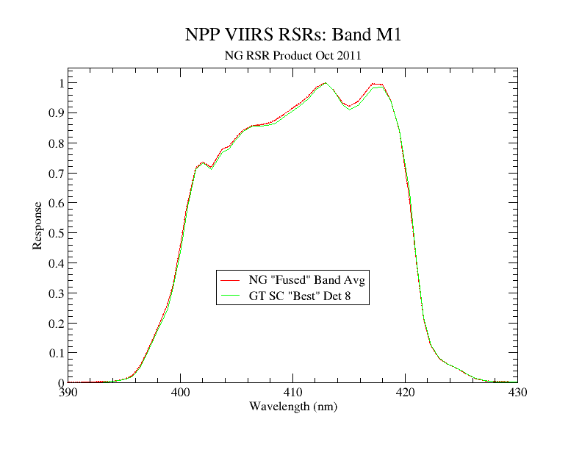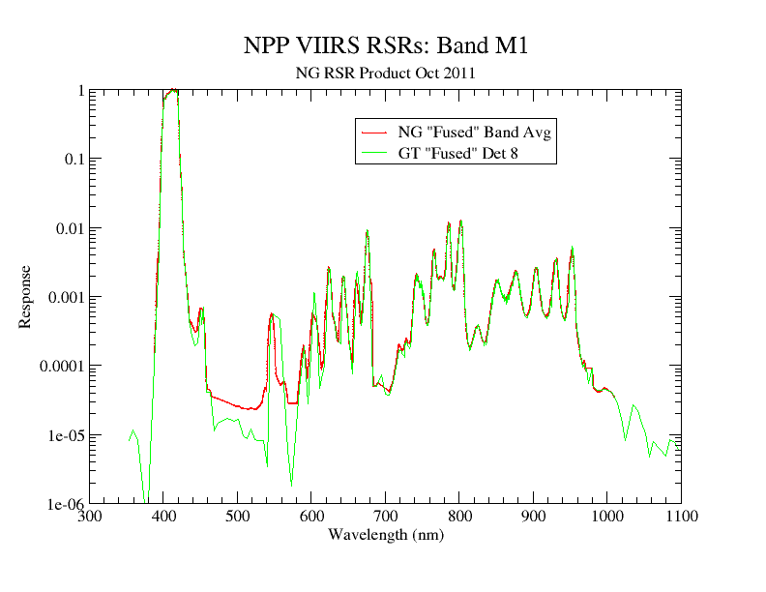
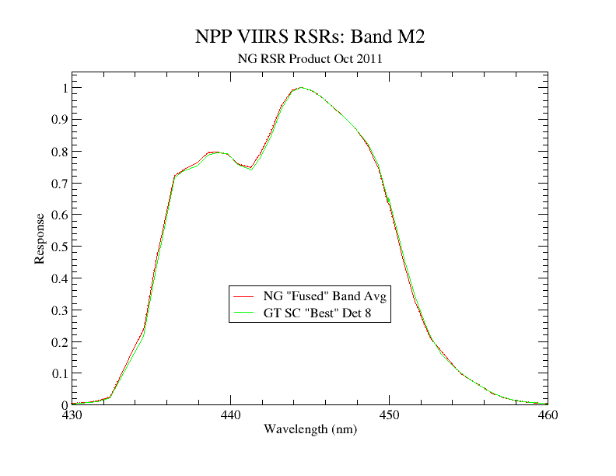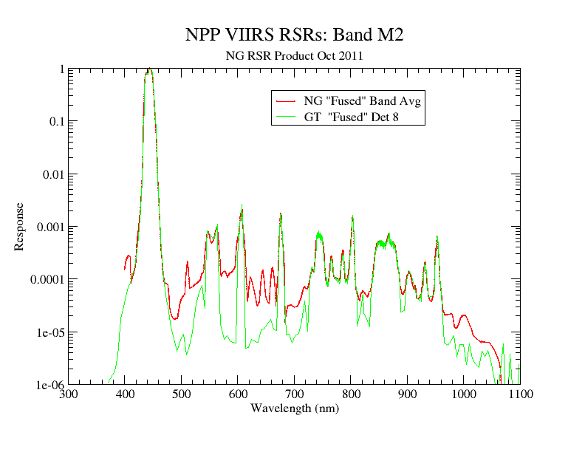
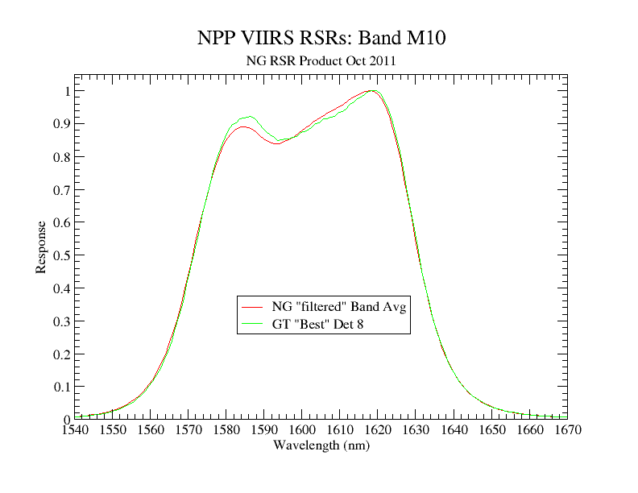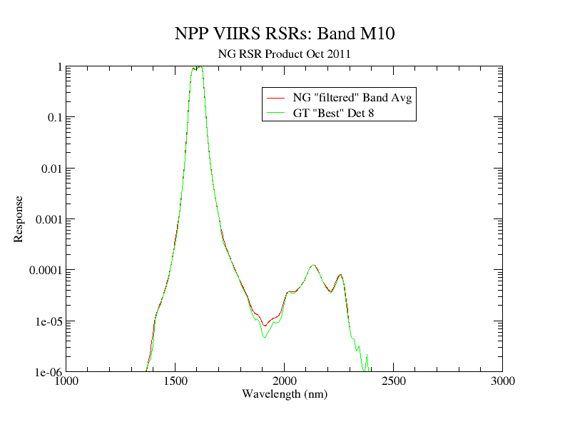
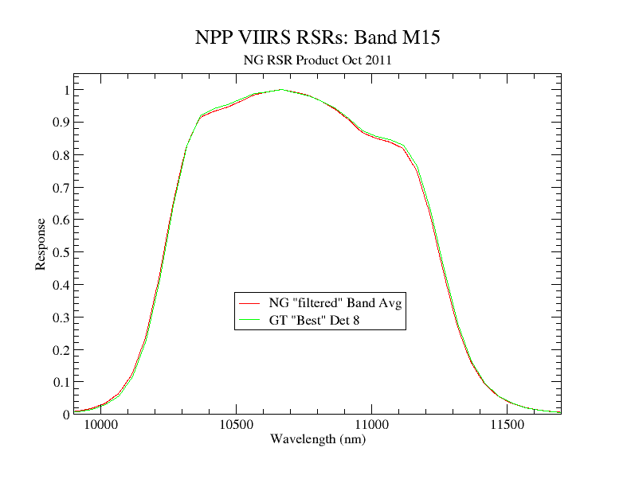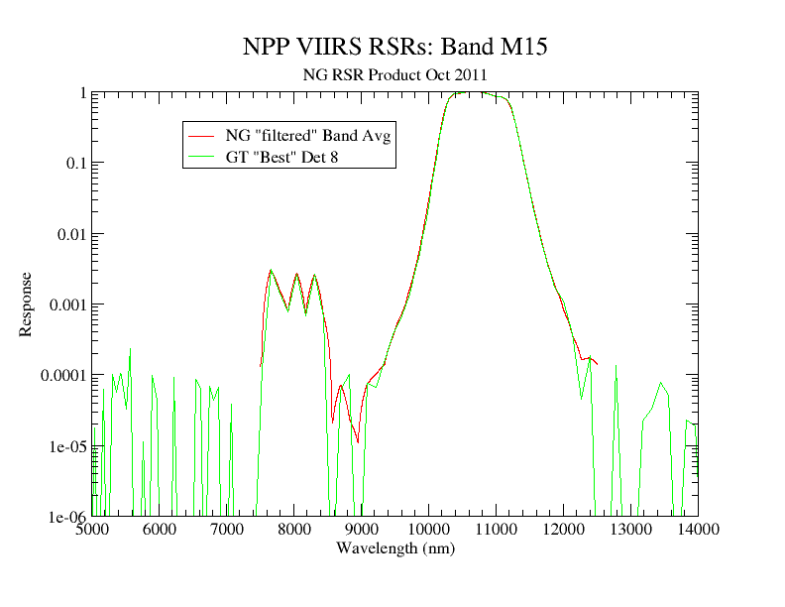

Figure 4. Comparison of NG band averaged RSR and Government team Detector 8 RSR
for in-band (left) and out-of-band (right) spectral regions.

Recommendations
The Government team recommends the use of NG Oct 2011 band averaged RSR for investigating and evaluating VIIRS product performance. The NG Oct 2011 band averaged RSR were used to populate the at-launch LUTs for VIIRS processing. The following supporting statements are provided:

- The NG fused RSR, using high quality spacecraft level RSR supplemented with high quality instrument level RSR to characterize spectral response for NPP VIIRS bands M1-M7, are the best characterization of RSR for these bands. The spacecraft level RSR provide the characterization for medium and high response wavelengths, taking advantage of cross talk characterization that is present in the spacecraft level RSR (and that will be present during VIIRS on-orbit operation), while the instrument level RSR provides useful characterization at low response wavelengths. Further:
  - High quality spacecraft level RSR is deemed preferable over that of high quality instrument level RSR at wavelengths where both are available. The Government team made its own determination and assignment of data quality through a Data Quality Flag and provided it with its spacecraft level “best” RSR release. NG adopted the data quality information to identify high quality wavelengths in their fused RSR for bands M1-M7.
  - The use of spacecraft level RSR at wavelengths where the data quality is low is not recommended. This position was also adopted by NG with some modification for a detector dispersion test on the response. The NG modification is deemed acceptable by the Government team.
  - Users of M1-M7 fused RSR or M1-M7 spacecraft level RSR are cautioned that electronic cross talk driven response is gain state dependent in the dual gain bands (M1 – M5, M7). Electronic cross talk driven response in the spacecraft level data was measured only for the “high” gain digitization state; it was not practical to confirm electronic cross talk behavior for “low” gain state. Users are cautioned in the use of electronic cross talk driven response for other than high gain state.
- The NG Oct 2011 band averaged RSR for SWIR (M8-M11), MWIR (M12-M13), and LWIR (M14-M16A,B) bands is acceptable to characterize spectral response for those bands. This is also the case for all I bands (I1-I5). The RSR for all of these bands is based upon instrument level measurements only (no spacecraft level measurements for bands M8-M16 or I3-I5; spacecraft level measurements for I1 and I2 were not ideal and were not applied by NG). The Government team RSR analysis closely corroborated the NG analysis for these bands.
- Government team instrument level RSR are a viable alternative to NG Oct 2011 RSR. The Government team RSR provide a high quality detector by detector RSR for all bands. It is noted however that radiometric impact of using Government team RSR compared to using NG band averaged RSR is expected to be very small or negligible, with differences in the NG and Government team RSR confined to very low response levels. Nevertheless, the Government team RSR will remain available to the community for their RSR related interests. Additionally, as warranted, the Government team may update its RSR to reflect new understanding of sensor performance as it is revealed in the post-launch era of NPP VIIRS.

RSR Data Availability
The NG band averaged at-launch RSR product and the Government team detector by detector RSR products are available at the NOAA JPSS web site at
https://cs.star.nesdis.noaa.gov/NCC/SpectralResponseVIIRS.

The NG band averaged at-launch RSR are available in files containing both the band averaged RSR plus the supporting detector level RSR (sensor order detector numbering only; see definition next paragraph) used to produce the band averaged RSR, or in files containing only the band averaged RSR. The data files along with a README are contained in zip files on the web site:
NG_VIIRS_NPP_RSR_filtered_Oct2011_BA_DET.zip (band avg and detector level)
NG_VIIRS_NPP_RSR_filtered_Oct2011_BA.zip (band avg only)

The Government team products are available for “sensor” and “product” order detector numbering. Sensor order detector numbering (leading detector in track direction assigned as detector #1) was employed during pre-launch testing; product order detector numbering (leading detector in track direction assigned as detector #16 for M bands or detector #32 for I bands) is considered to be convenient when working with on-orbit data as the first data line in a VIIRS granule is intuitively assigned as detector #1.

Government Team Point of Contact List
For questions on this document or related NPP VIIRS RSR matters contact:

Chris Moeller, Univ. Wisconsin, chrism@ssec.wisc.edu
Tom Schwarting, NICST, thomas.schwarting@sigmaspace.com
Jeff McIntire, NICST, jmcintire@sigmaspace.com

APPENDIX A

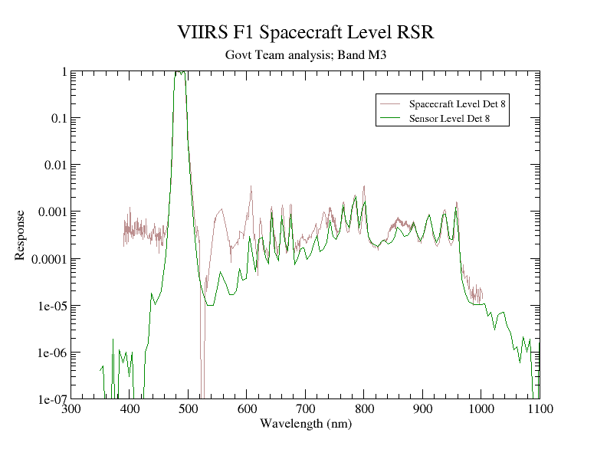
Figure A1. Comparison of band M3 instrument and spacecraft level RSR for detector 8.

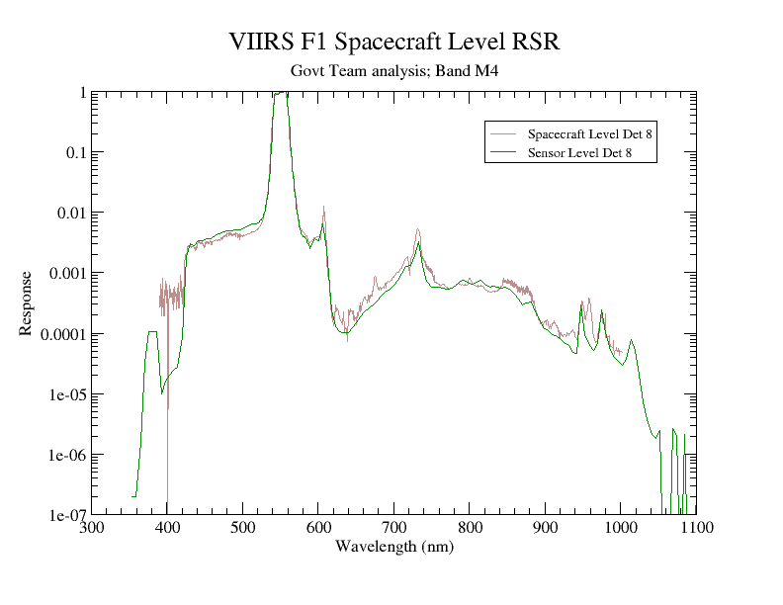
Figure A2. Comparison of band M4 instrument and spacecraft level RSR for detector 8.
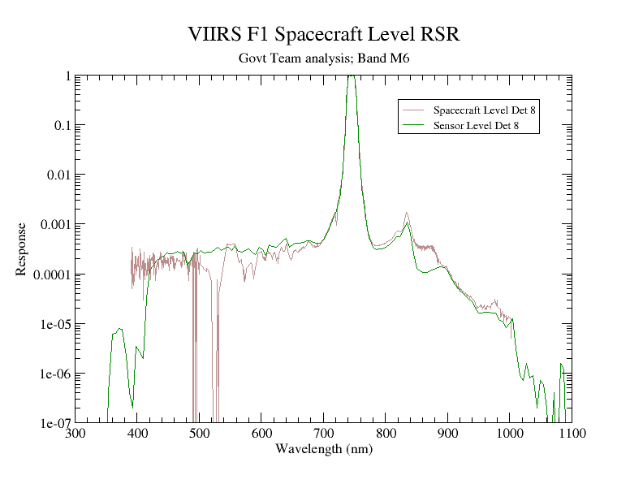
Figure A3. Comparison of band M6 instrument and spacecraft level RSR for detector 8.

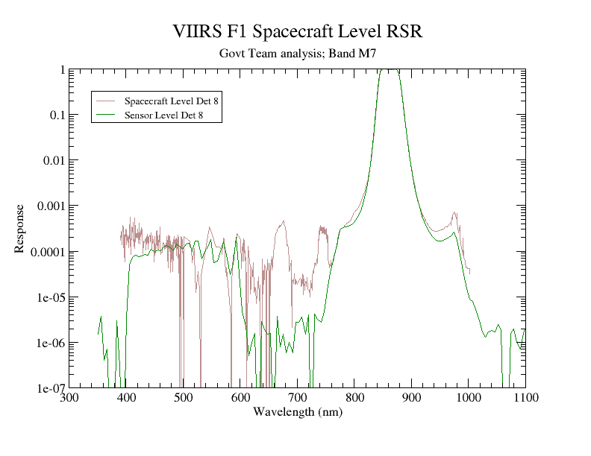
Figure A4. Comparison of band M7 instrument and spacecraft level RSR for detector 8.

APPENDIX B

Comparisons of NG band averaged RSR to Government team detector 8 (M band) or 16 (I band) RSR for in-band (left) and out-of-band (right) spectral regions. Provided for all VIIRS bands except DNB.

