SNPP Satellite Data Products and Imagery for Detecting Paraguay Flooding
Submitted July 14th, 2014

The National Environmental Satellite, Data, and Information Service (NESDIS)

Center for Satellite Applications and Research (STAR)

Joint Polar Satellite System (JPSS) STAR (JSTAR)

From Mid-June of 2014, floods caused by torrential rains have forced the evacuation of 200,000 people living near the Paraguay and Parana rivers. As many as 160,000 people have been affected in Paraguay alone. Following a request from Laura Furgione (National Weather Service [NWS] DAA) to Mark Paese (NESDIS DAA) and Al Powell (STAR Director), JSTAR coordinated with the JSTAR science teams as well as JPSS Proving Ground and Risk Reduction (PGRR) flooding team for providing high resolution images and product maps over the flooding area along the Paraguay and Parana rivers. A webpage including the latest high resolution satellite imagery and data product maps have been put together on the STAR web server: http://www.star.nesdis.noaa.gov/jpss/ParaguayFlooding.php. The webpage allows viewing the imagery before and after the flood to see the impacts of flooding to the area, the imagery and data files in GIS format (as requested) are also available to be downloaded from the page. A few product imagery and data products generated for this purpose are briefly described in following.
VIIRS imagery (POC: Don Hillger don.hillger@noaa.gov): High resolution VIIRS imagery (350 meters) was provided by the Imagery Environmental Data Record (EDR) team (Don Hillger, Dan Lindsey, CIRA) showing significant flooding of the Paraguay River near the Paraguayan capital of Asuncion. The image below is a natural color example generated from VIIRS bands I-1, -2, and -3 showing the swollen river on June 30, 2014. Also provided were raw but enhanced I-band-1 images both before and after the flooding in order to assess its extent.
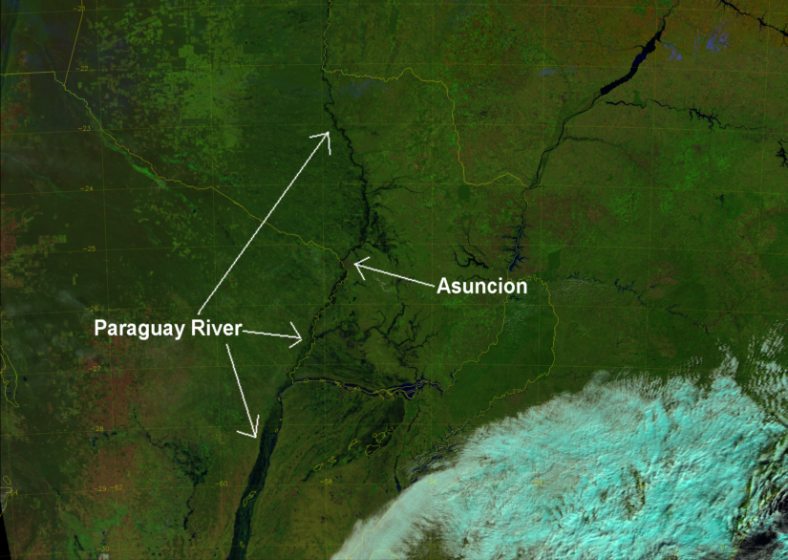

Figure 1 VIIRS natural color image (I-bands-1, -2, and -3) over South America from June 30 2014 showing river flooding near Asuncion, Paraguay (by Curtis Seaman, Cooperative Institute for Research in the Atmosphere [CIRA])
Surface Type Map (POC: Jerry Zhan xiwu.zhan@noaa.gov): The University of Maryland Surface Type data product team led by NOAA-NESDIS Center for Satellite Applications and Research has created a flood area map using the VIIRS surface reflectance data of I1, I2 and I3 channels of June 2 before and June 30th, 2014 after the flooding(See Fig. 2). A classification algorithm called Support Vector Machine (SVM) is employed to totally 6 classification metrics based on the three channel surface reflectance. The flood area map demonstrated the flooded areas as well as the surface types of the river basins.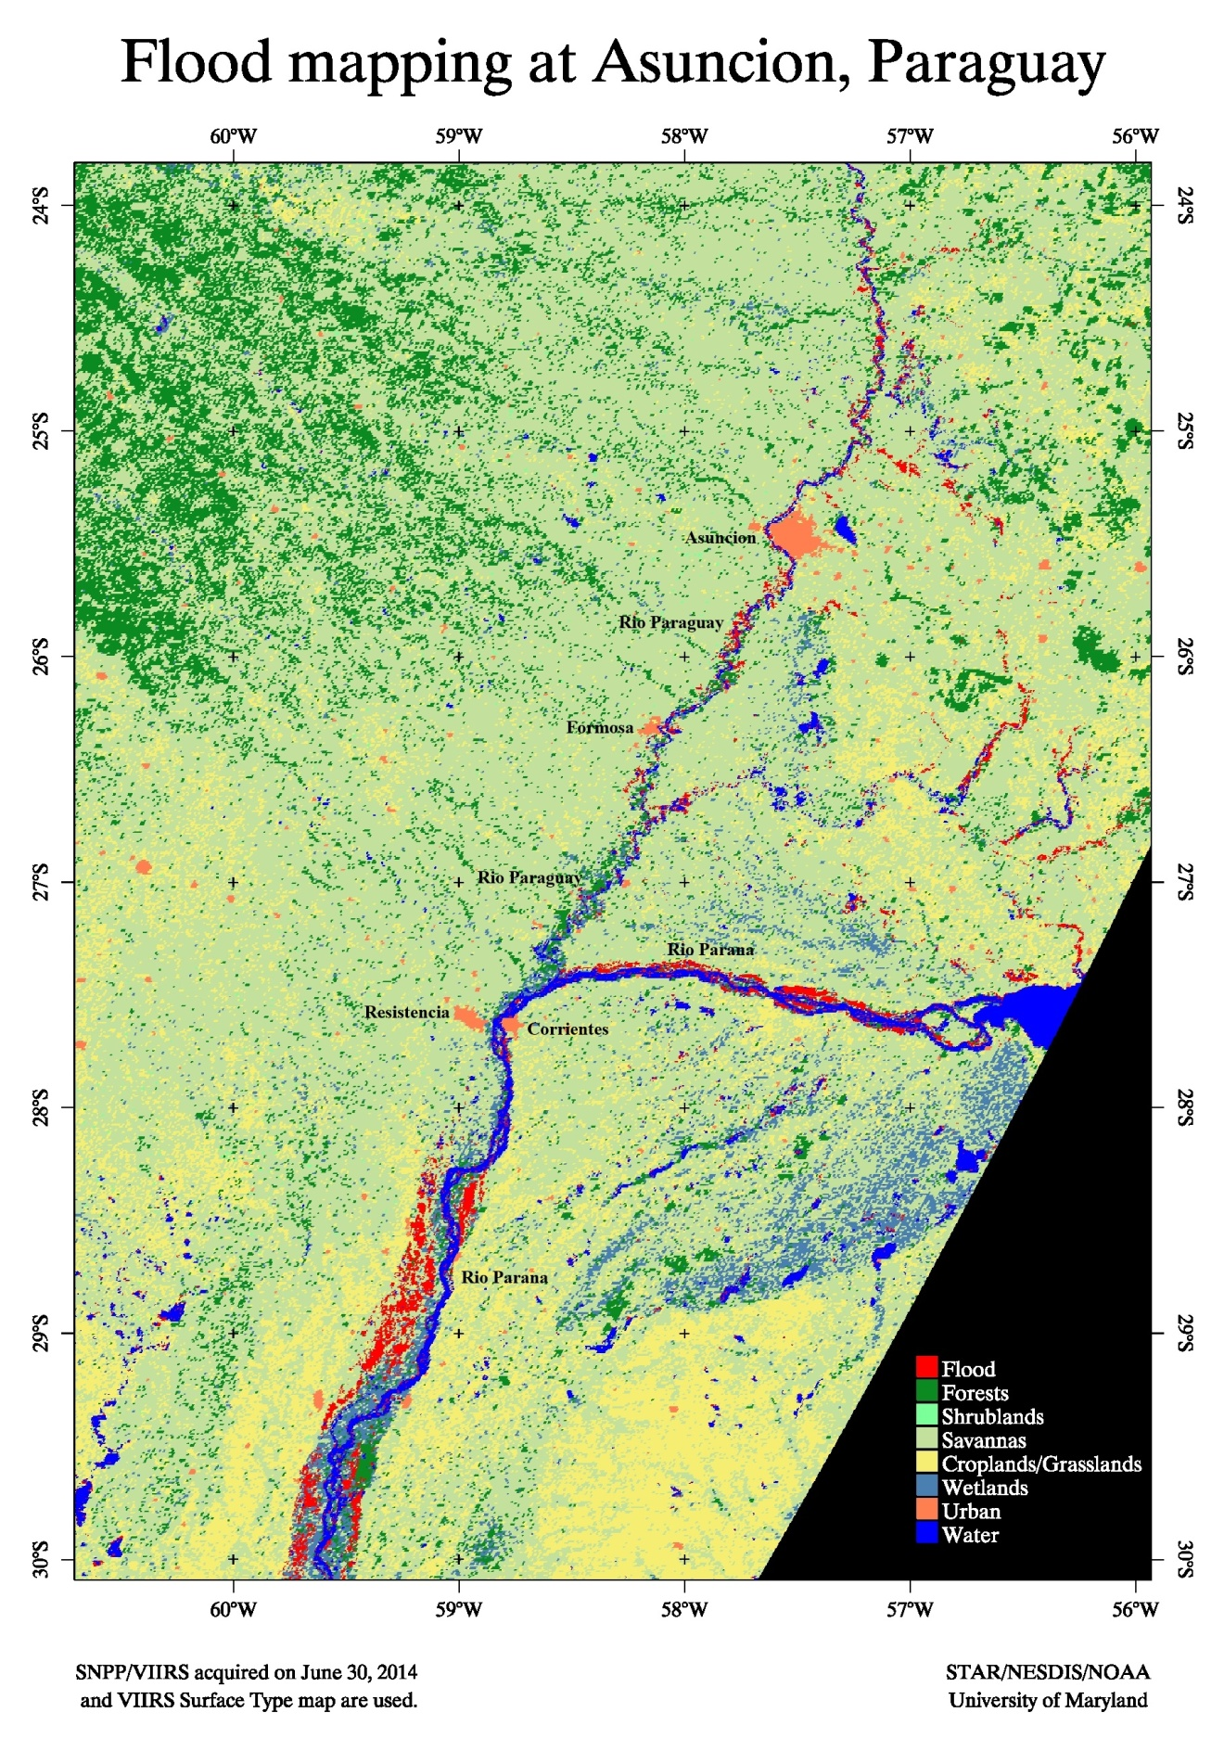
Figure 2 Flooding map generated by the STAR JPSS Surface Type team

The Surface Type team is following up this flood event, and more flood related maps may be updated later.
JPSS Proving Ground Risk Reduction (PGRR) Flooding Product (POC: Donglian Sun donglian.sun@gmail.com): VIIRS flood product is an automatic product for near-real-time flood detection at regional or global scale. It is generated by VIIRS flood detection package developed by George Mason University (GMU). The package includes a series of algorithms varying from water detection, cloud shadow removal, water fraction retrieval, flood determination and integration of water fractions and DEM for high resolution water map generation. To guarantee the stability of flood detection, cloud and snow/ice detection are also included along with the use of VIIRS cloud mask product. The flood product shows good capability in flood detection.

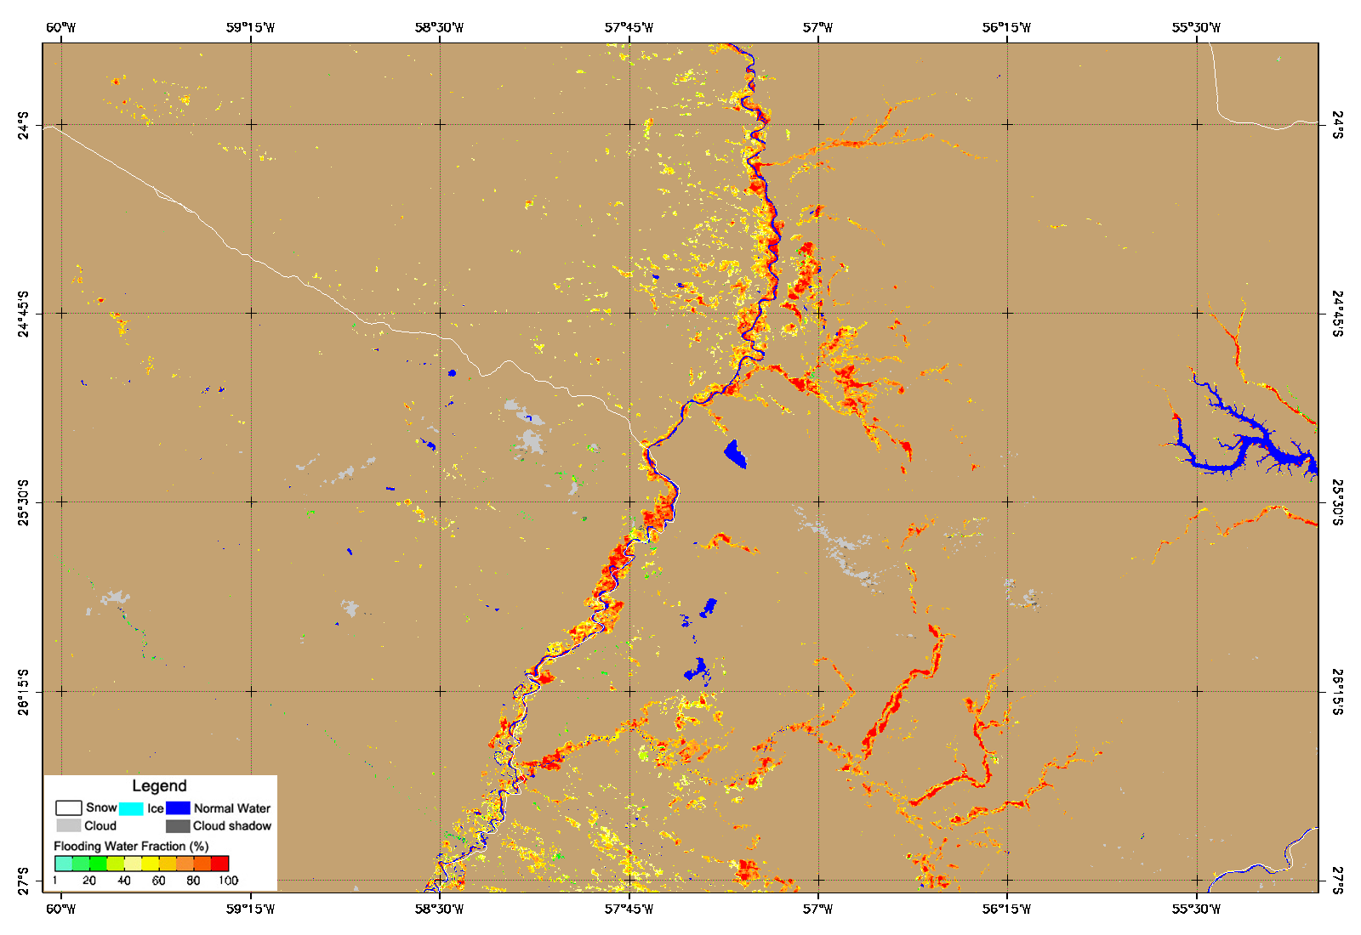
Figure 3 Flooding/Water map generated by the GMU JPSS PGRR Flooding team

A new experimental flooding product derived from VIIRS data with improved resolution (90m) using the Digital Elevation Map (DEM) to detect the flood spreading across the area has also generated. In general it seems the maps can capture the flood features quire well. It would be very helpful to get some in-situ verification/validation of the products.

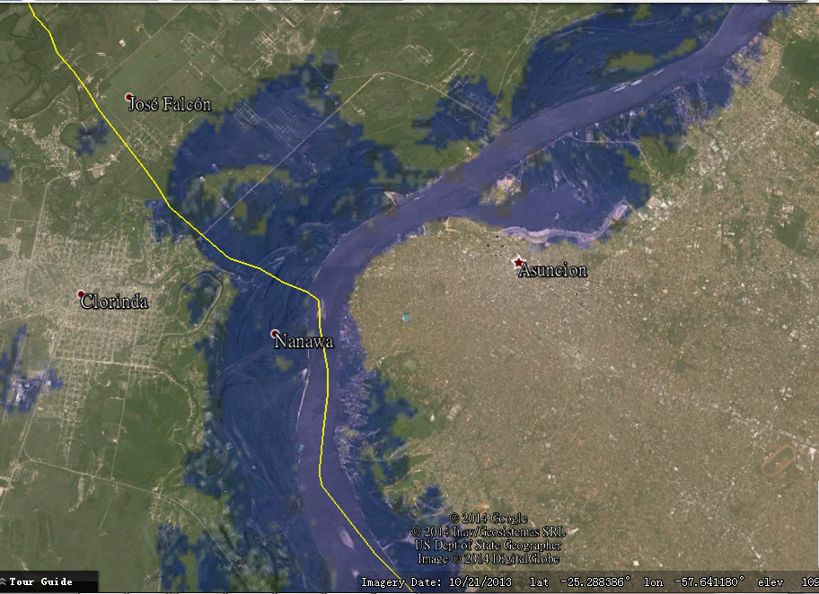
Figure 4 A close view of flood in Paraguay near Asuncion on June 30, 2014 by using VIIRS 90-m water map (generated by Sanmei Liu, GMU)

More information and imagery can be found at: http://www.star.nesdis.noaa.gov/jpss/ParaguayFlooding.php
- Surface Type Map
- False Color Image
- Flood Map
- VIIRS 90 m Water Mask TFW
- VIIRS 90 m Water Mask TIFF
- Googe Earth VIIRS I1 Band Overlay
- VIIRS I-1 band Before and After
- Overview Powerpoint
- VIIRS I-1 Band Imagery, Flood Map, and False color
- Natural Color Before
- Natural Color After
- Flood Map TIFF
Comments/feedback please email to: Lihang Zhou ( Lihang.Zhou@noaa.gov)

