NUCAPS Probes Historic Southern Hemisphere
Sudden Stratospheric Warming (SSW) Event
(Tony Reale)

NOAA Unique Combined Atmospheric Product System (NUCAPS) atmospheric sounding products are typically of value to weather forecast users focused on severe weather applications in the troposphere (below 5km). However these soundings are produced up to 1 hPa (50km) and include reliable temperature profiles through the stratosphere. Beginning in late August, Southern Hemisphere (SH) meteorologists began noticing the onset of what would become an historic sudden stratospheric warming (SSW) event high above Antarctica with continued intensification through September.
Stratospheric warming although common in the northern hemisphere is rare in the SH. Normally, the advent of SH summer warming weakens the polar vortex and associated westerly winds circumnavigating Antarctica in the “stratosphere”, but in rare, extreme cases these can reverse direction and become easterlies, the technical definition of an SSW. The net result is a more northward shift of the Southern Ocean westerly winds circumventing the middle latitudes in the “troposphere”. This can have a significant (and sustained) impact on the weather, including enhanced springtime temperature increases, droughts and higher fire risk in southern and eastern Australia as currently being observed in New South Wales and Queensland.
The two panels of Figure 1 show SH polar projections of NUCAPS stratospheric temperature fields at 10 hPa (30km) during September 2018 (left) and 2019 (right). The SSW anomaly (red) approaches 40K and oriented due north of Australia; associated cooling (purple) affirms the interrupted stratospheric westerly.

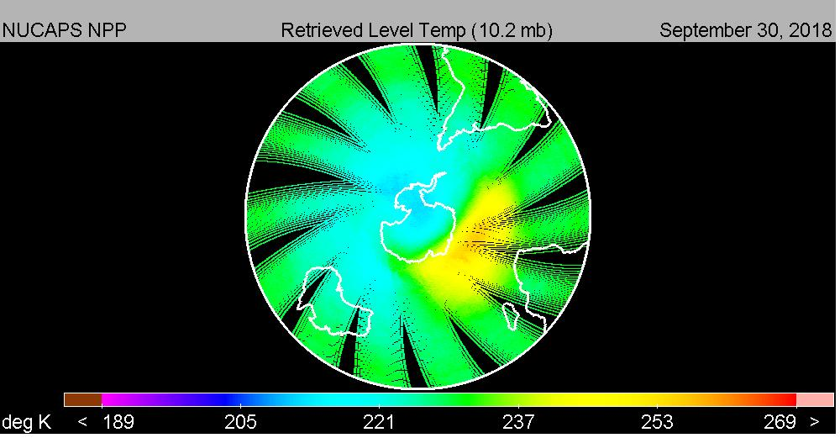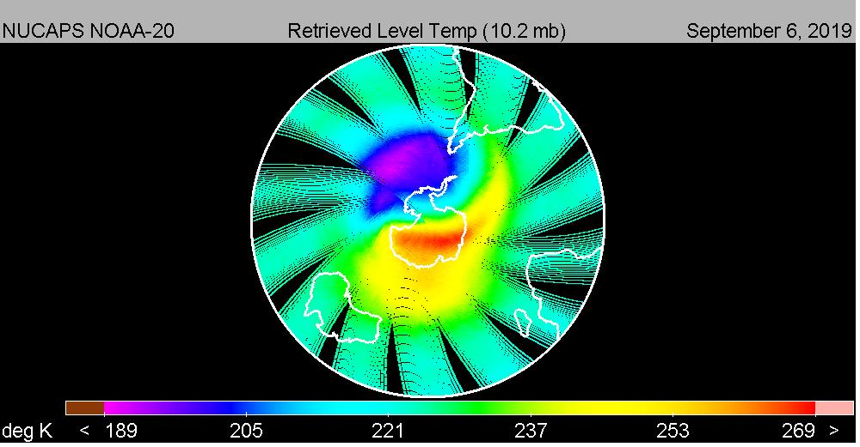
Figure 1: NUCAPS 10 hPa (25km) temperature fields displayed in SH polar projection during September 2018 (left) and September 2019 (right); the red area highlights the SSW event

Interestingly, SSW initiates at the surface with the warming signature in the stratosphere indicative of an organized vertical air current through the troposphere and stratosphere with enough energy to shift (and sustain for several months) the tropospheric westerly and jet stream pattern which ultimately steer the weather; Figure 2.

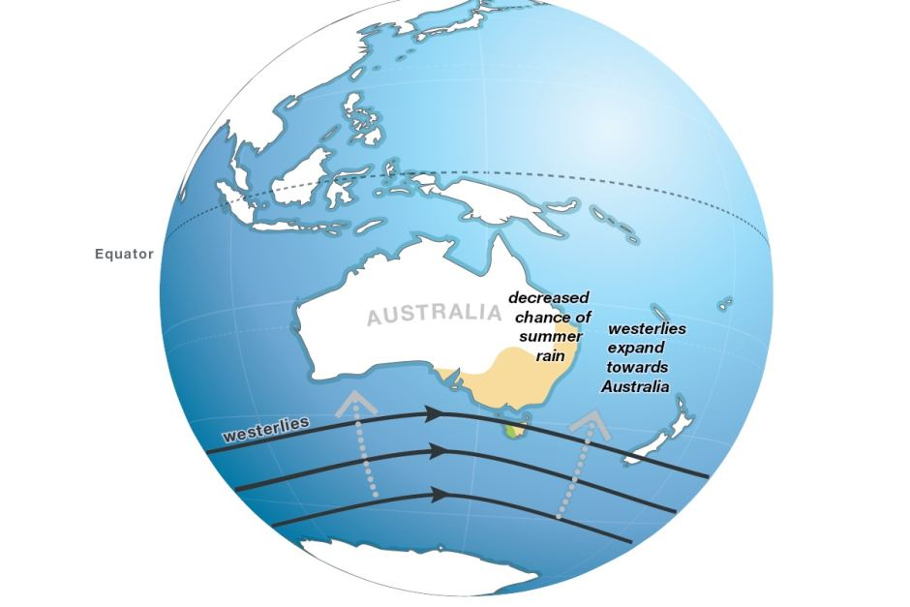
Figure 2: Typical northward shift in SH tropospheric westerlies associated with SH-SSW events underlying the severe drought and brush fires in southeast Australia (2).

The six panels of Figure 3 illustrates the vertical structure of the SSW event (and vertical current) using NUCAPS derived temperature fields (bottom left to top right) at 200 hPa (12km), 150 hPa (14km), 100 hPa (16km), 50 hPa (20km), 10 hPa (30km) and 1 hPa (50km). Stratospheric intrusions or “hot spots” (red)” in the vicinity of 200 hPa (tropopause) are typically associated with strong cold fronts and appear to dissolve in the stratosphere. However, the “hot spot” to the south and east of Australia is seen to retain its identity through the stratosphere shifting northward (and slightly east) with height and atop the pole at 1 hPa denoting an SSW event..

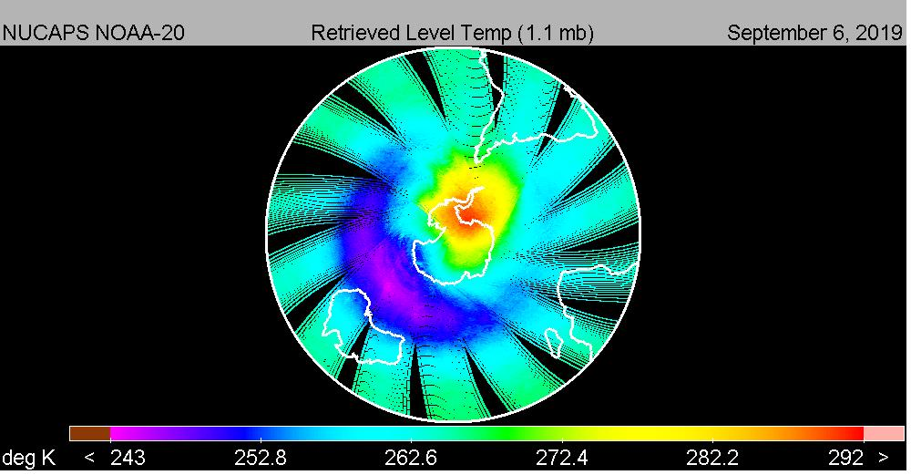
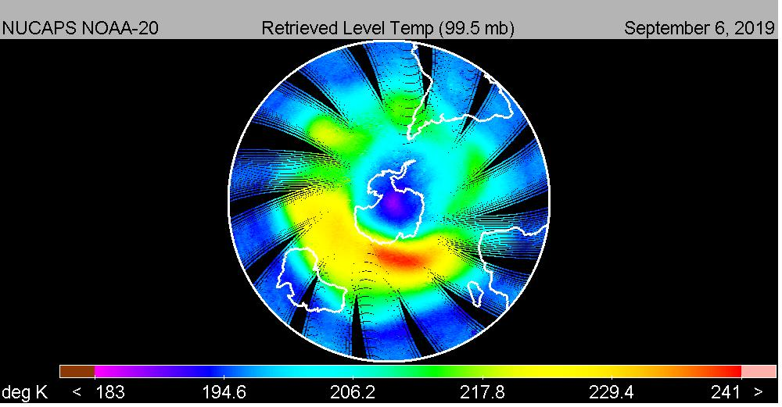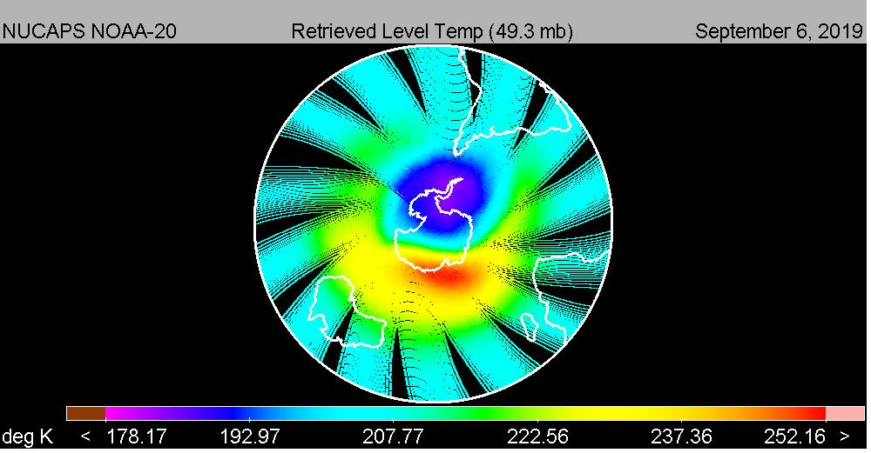
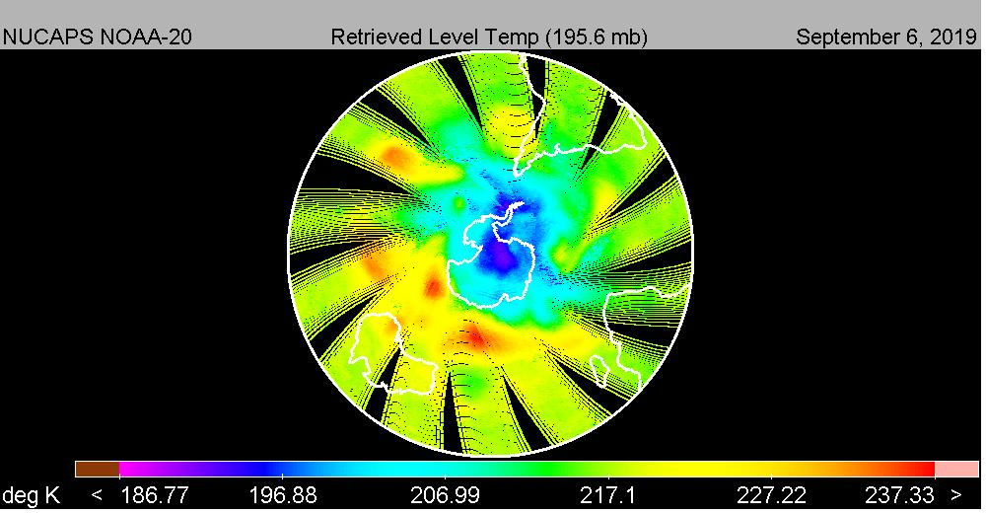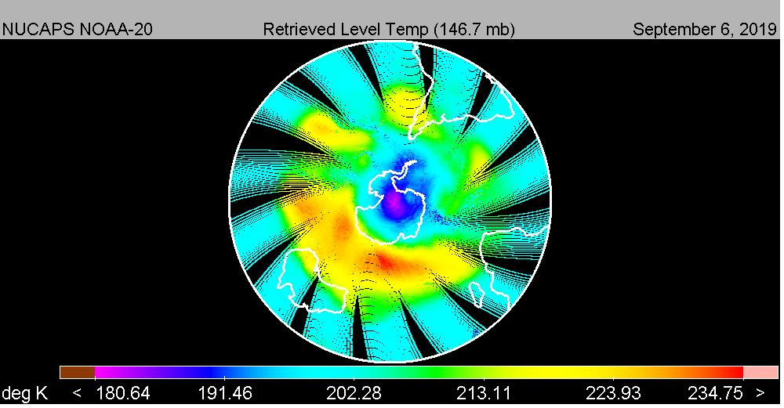

Figure 3: NUCAPS temperature fields displayed in SH polar projection ranging from 200 hPa (12km, lower left) to 1.0 hPa (50km, upper right) during September 2019 SSW event; the isolation and vertical displacement of the SSW feature is evident.

The 2 panels of Figure 4 show NUCAPS temperature fields at 10 hPa three months later during December 2019 (left) and December 2018 (right) using the same temperature color scale as the September 2019 fields (Figure 2). The SSW event is no longer observed but its impact on Australian weather remains highly evident.

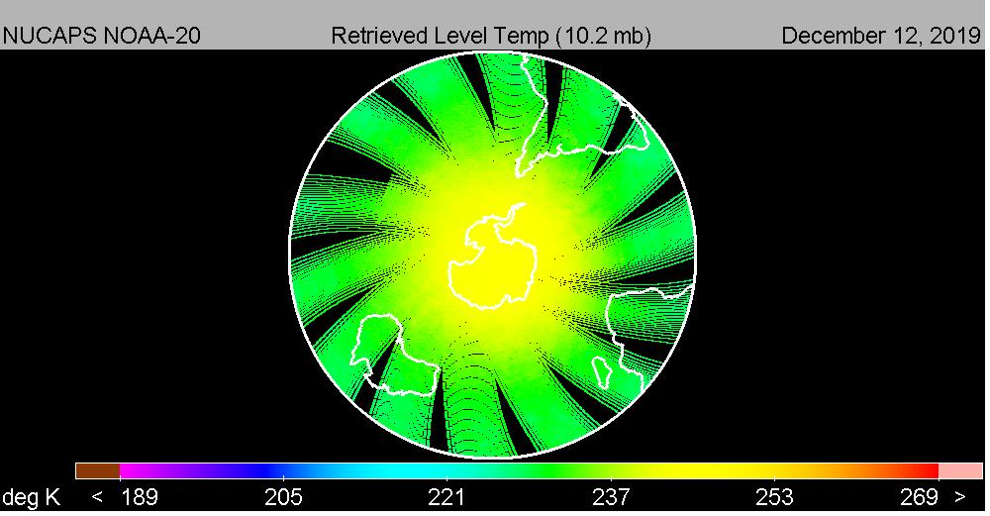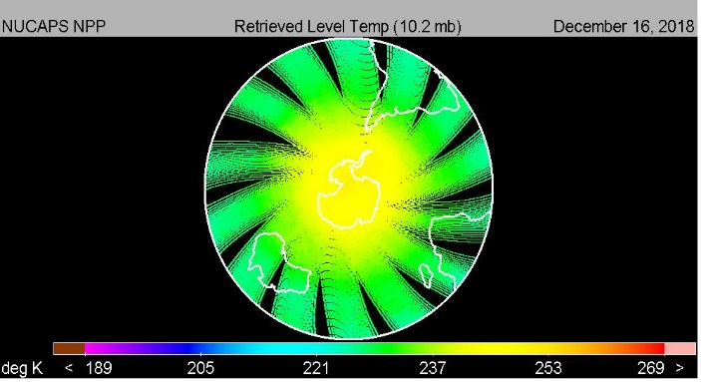
Figure 4: NUCAPS 10 hPa (25km) temperature fields displayed in SH polar projection during December 2018 (left) and September 2019 (right); the SSW event appears over but impacts on Australia weather persists.

In summary, the NUCAPS soundings delineated the onset of SSW in the SH this past September that set into motion large scale tropospheric weather shifts leading to the sustained heat, drought and brush fires in south eastern Australia two months later. NUCAPS represents a unique source of independent geophysical observations of value to weather forecasters particularly in data sparse regions. Typically of interest in the troposphere, NUCAPS also provides reliable temperature profiles through the stratosphere with good sensitivity to anomalies such as SSW.

Reference:
1) https://www.sciencealert.com/antarctica-s-sudden-stratospheric-warming-is-impacting-australia
2) https://www.abc.net.au/news/2019-09-06/rare-weather-event-over-antarctica-drives-hot-outlook/11481498

Notes
Highlights from References

The warming began in the last week of August, when temperatures in the stratosphere high above the South Pole began rapidly heating in a phenomenon called "sudden stratospheric warming".
In the coming weeks the warming is forecast to intensify, and its effects will extend downward to Earth's surface, affecting much of eastern Australia over the coming months.
The Bureau of Meteorology is predicting the strongest Antarctic warming on record, likely to exceed the previous record of September 2002.

Every winter, westerly winds – often up to 200 kilometre per hour (120 miles per hour) – develop in the stratosphere high above the South Pole and circle the polar region.
The winds develop as a result of the difference in temperature over the pole (where there is no sunlight) and the Southern Ocean (where the sun still shines).
As the sun shifts southward during spring, the polar region starts to warm. This warming causes the stratospheric vortex and associated westerly winds to gradually weaken over the period of a few months.

However, in some years this breakdown can happen faster than usual.
Waves of air from the lower atmosphere (from large weather systems or flow over mountains) warm the stratosphere above the South Pole, and weaken or "mix" the high-speed westerly winds.
Very rarely, if the waves are strong enough they can rapidly break down the polar vortex, actually reversing the direction of the winds so they become easterly. This is the technical definition of "sudden stratospheric warming."
Although we have seen plenty of weak or moderate variations in the polar vortex over the past 60 years, the only other true sudden stratospheric warming event in the Southern Hemisphere was in September 2002.
Impacts from this stratospheric warming are likely to reach Earth's surface in the next month and possibly extend through to January.
Apart from warming the Antarctic region, the most notable effect will be a shift of the Southern Ocean westerly winds towards the Equator.
For regions directly in the path of the strongest westerlies, which includes western Tasmania, New Zealand's South Island, and Patagonia in South America, this generally results in more storminess and rainfall, and colder temperatures.
But for subtropical Australia, which largely sits north of the main belt of westerlies, the shift results in reduced rainfall, clearer skies, and warmer temperatures.
Past stratospheric warming events and associated wind changes have had their strongest effects in NSW and southern Queensland, where springtime temperatures increased, rainfall decreased and heatwaves and fire risk rose.

