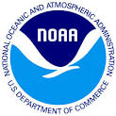 | General Comments Form | 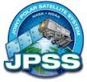
2014 STAR JPSS Science Teams Annual Meeting
May 12 - 16, 2014
NCWCP, College Park, MD

Originator: Phone #: Org:
Name
Title:
Comment/ Recommendation (include presentation section and page #)

Rationale:

Clarification:

Assigned To: Assignee Phone #:

Date Closed:

